**University of Salford**

**NAME: Stephen Okpiaifoh**

**Email: s.okpiaifoh@edu.salford.ac.uk**

**Department: Data Science**

**Course code: SG-G340-M0002-41141-22**

**Course Title : Big Data Tools and Techniques**

**1.0 Description of setup required for RDD in Pyspark(Databricks)**

The setup for pyspark in Databricks RDD, which also includes importing libraries to prepare the pyspark environment .

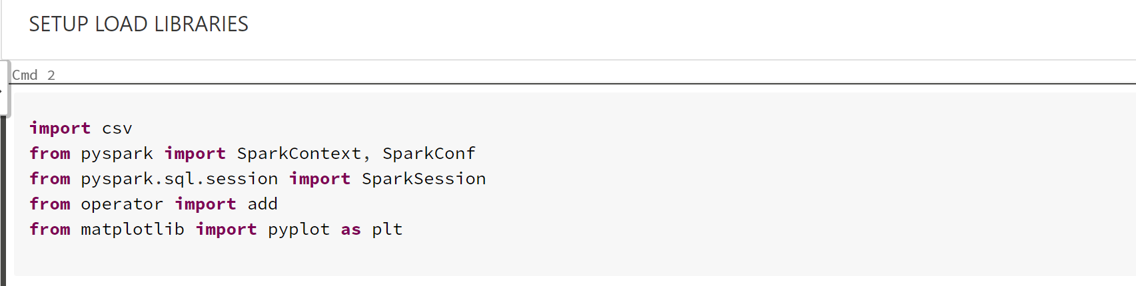

**1.1 Loading Data**

The below data uploaded from blackboard to databricks "/FileStore/tables/" and renamed

**Data inspection to see if it exits** as follows

1. Clinicaltrial_2021
2. Pharma
3. mesh

**in FileStore**

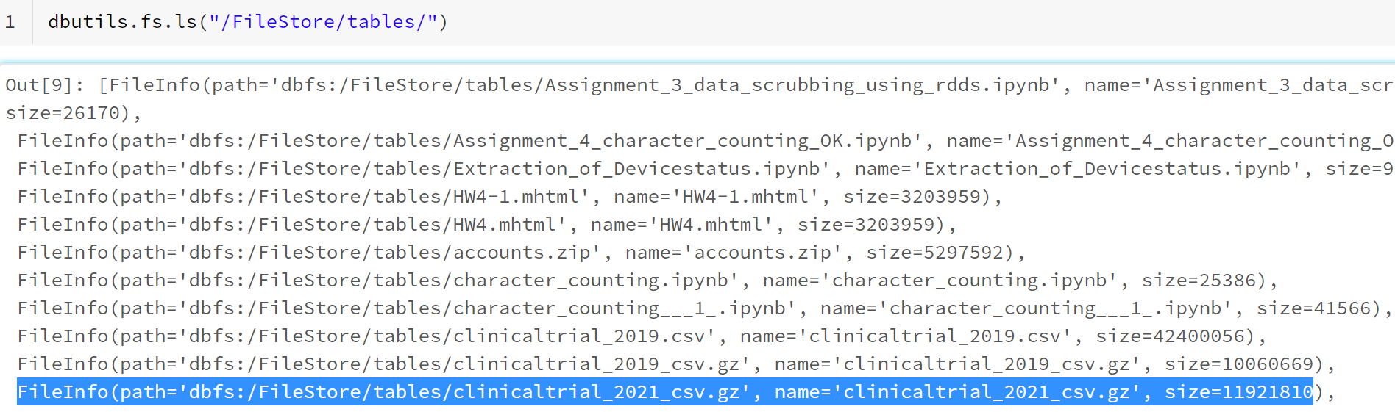

**1.2 Importing data:**

The data was set in import os environment it enables it to be reproducible by just changing the versions as shown below. I must move the data using databricks utilities (dbutils.fs.cp) to copy the file to /tmp/ for temporary storage.

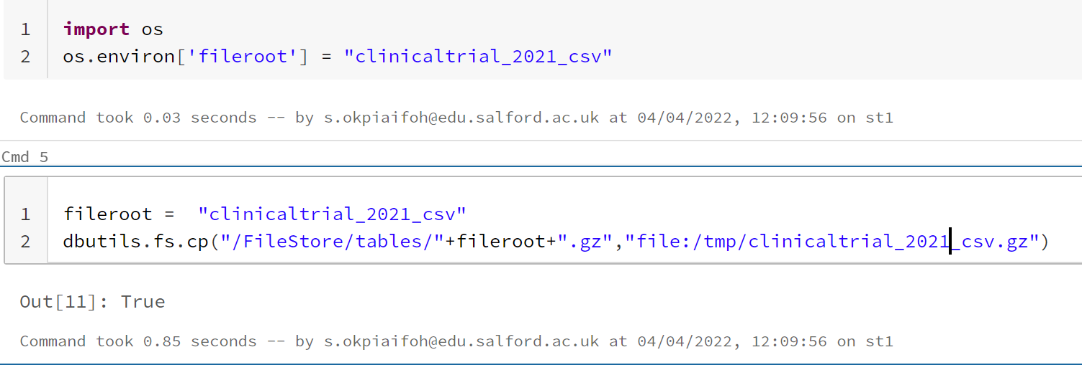

Since the data contains an extension gz file, I need to unzip the file in databricks so I can read and analysis the data easily. The gun zip function was used to unzip the clinicaltrial_2021 file.

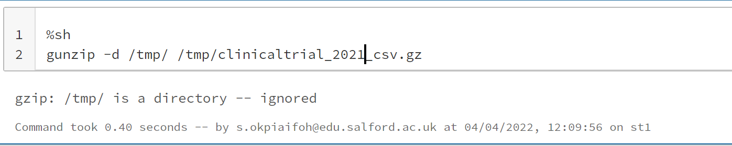

The data ready to be moved back to dbfs:FileStore from /tmp/ storage for Analysis as below.

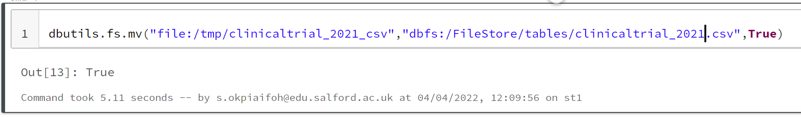

**1.3 Viewing the head of the data clinicaltrail_2021 to and know see the formation and know what cleaning to be conducted.**

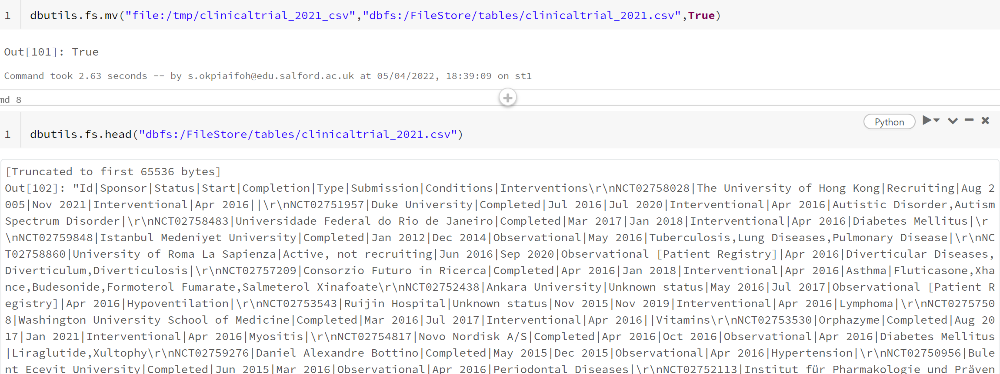

**1.4 Renamed data by assigning a variable name called clinicaltrial_2021 and indicating file location**

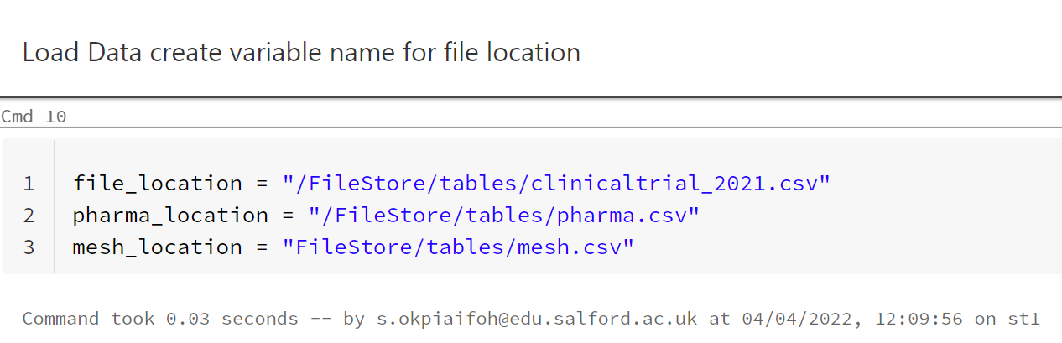

**1.5 Loading data from File location in FileStore to databricks notebook**

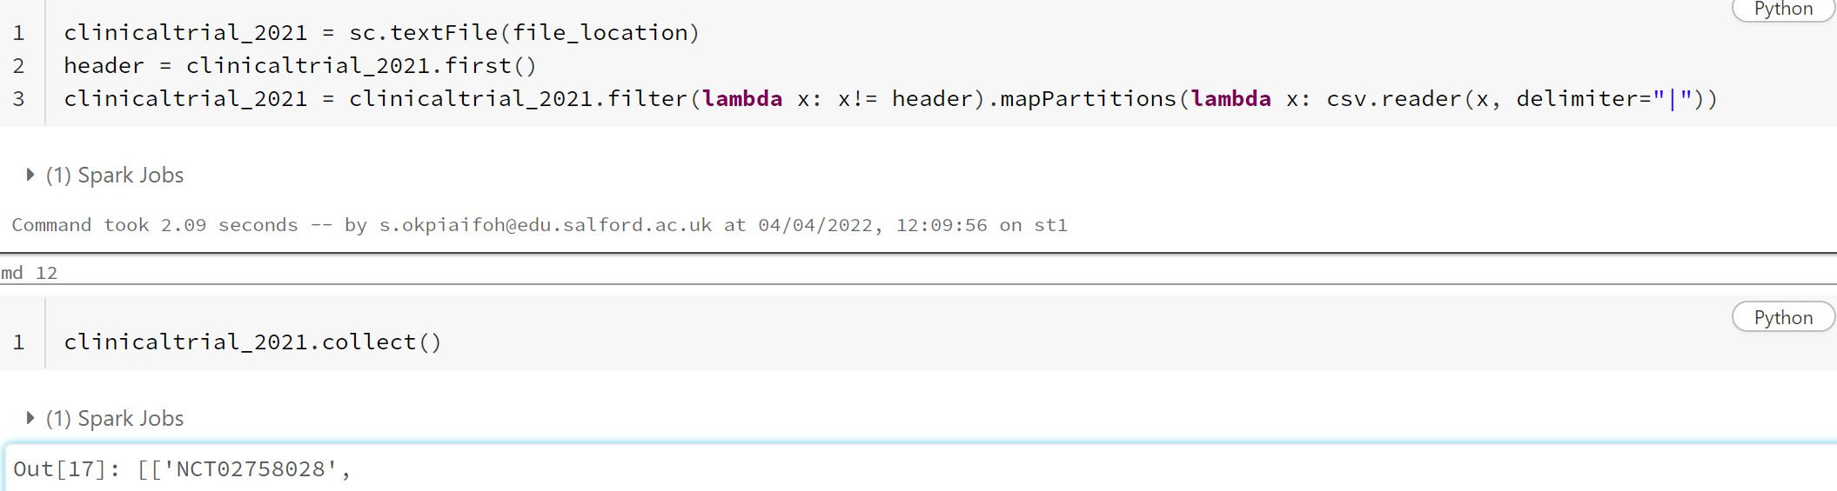

**1.6 Preparation and cleaning of data**

Since column name which is company name is not part of the work including it in the data can affect counting and during indexing it can result to wrong indexing of element in my result. Filter function is included in the code to filter out the header before loading the dataset to pyspark python notebook as show below.

Map partitions is applied to enable me to have an initialization once on the data instead of doing it several times on the RDD, it also helps in performance of the job when dealing with heavy-weighted initialization on larger dataset. As show below code

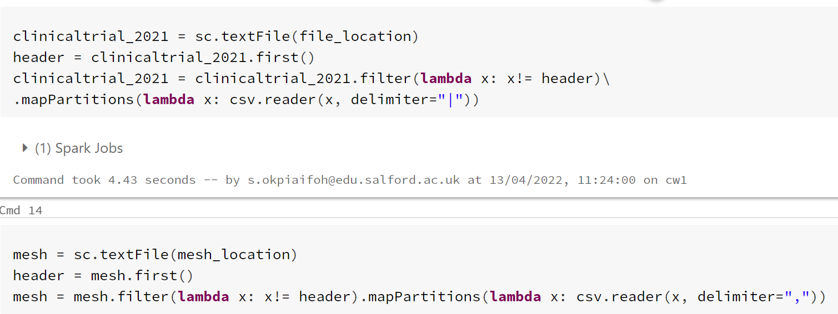

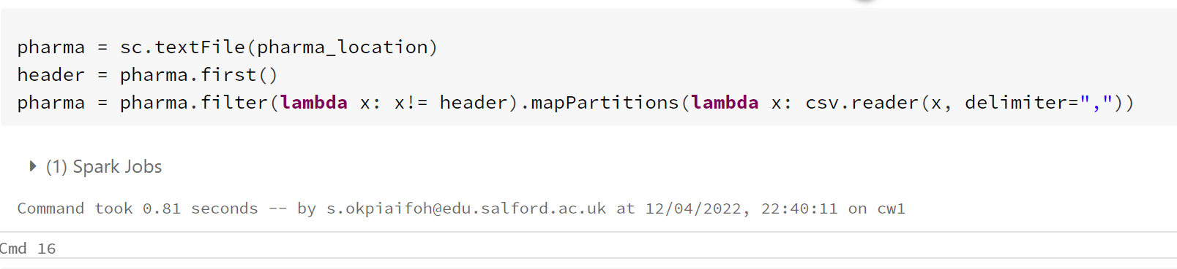

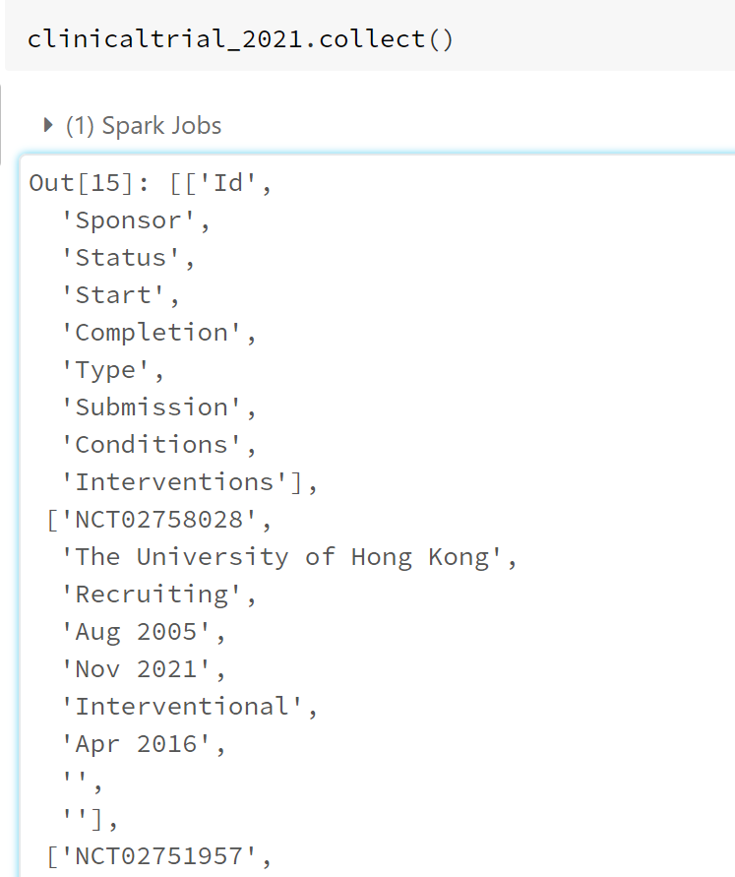

**2.0 HIVEQL SETUP**

A new notebook called HIVEQL was opened in databricks, Language changed to SQL.

**2.1 DATA LOADING FROM FileStore/tables to PySpark notebook as shown below with codes. Table created are:**

1. clinicaltrial_2021

2. pharma

3. mesh

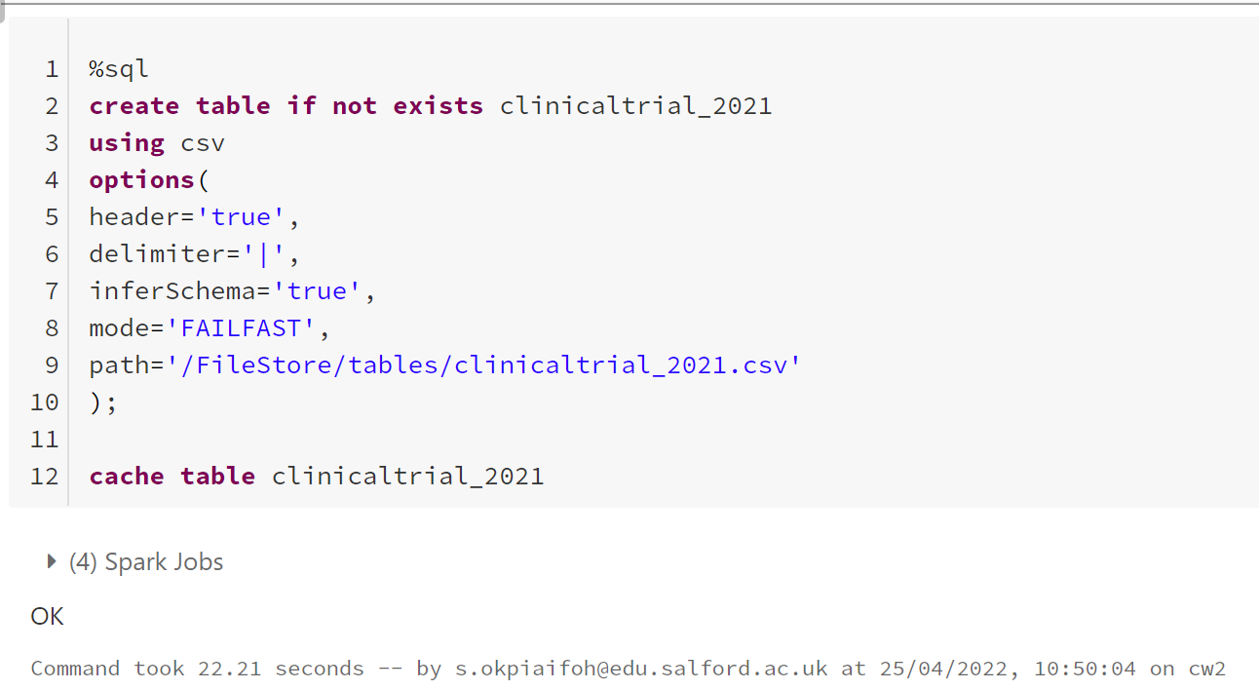

**Code 1 creating table called clinicaltrial_2021 table**

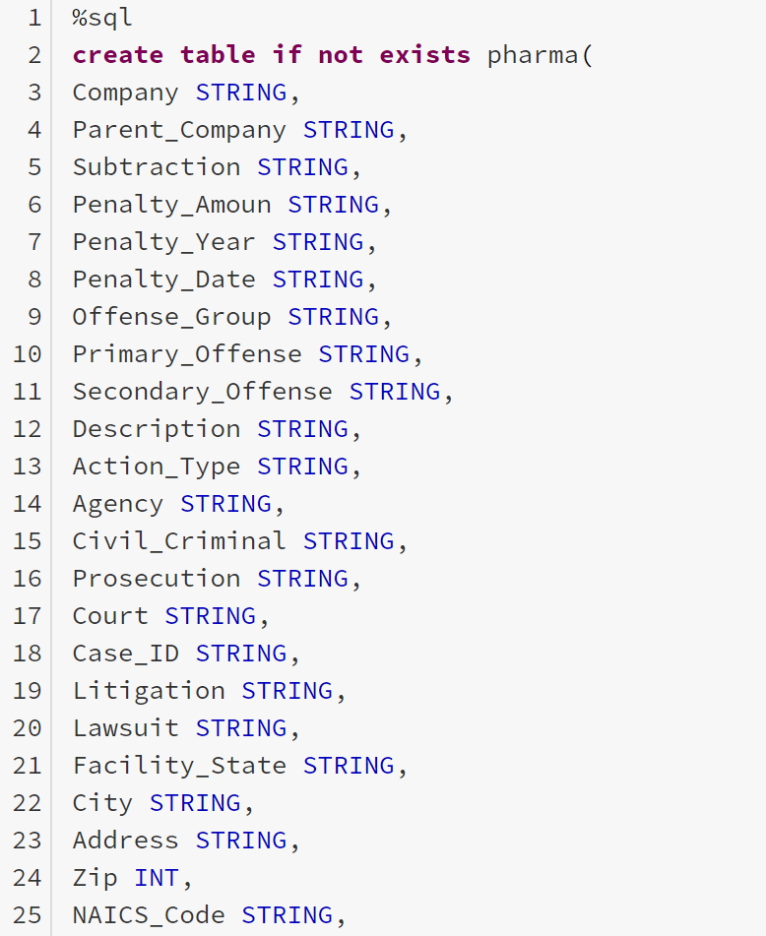

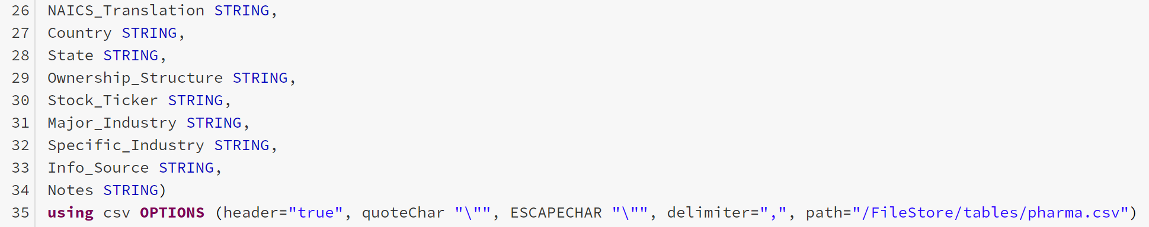

**Code 2 pharma table.**

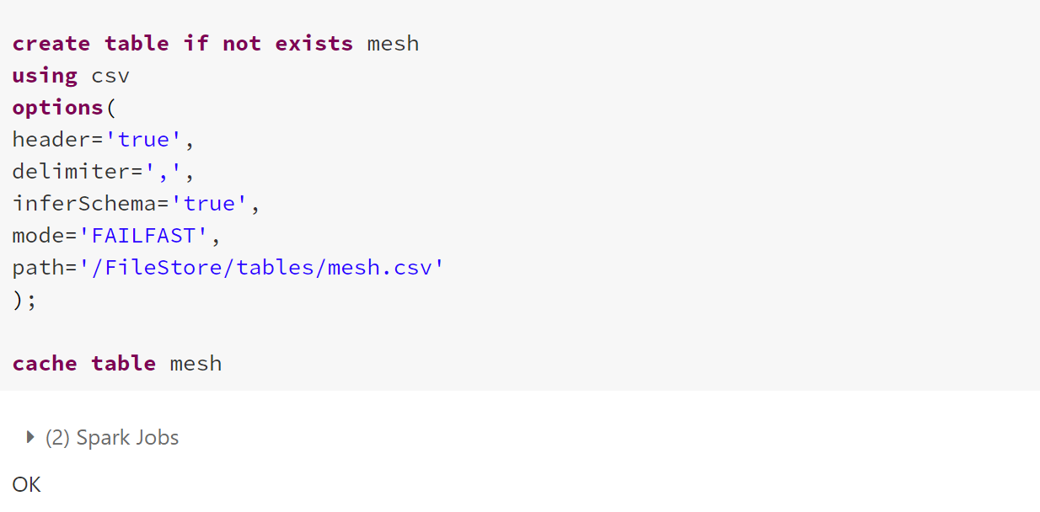

**Code 3. mesh table**

**2.2 critical view of the tables created, limiting display to five.**

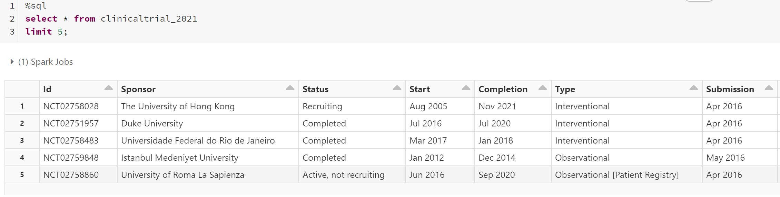

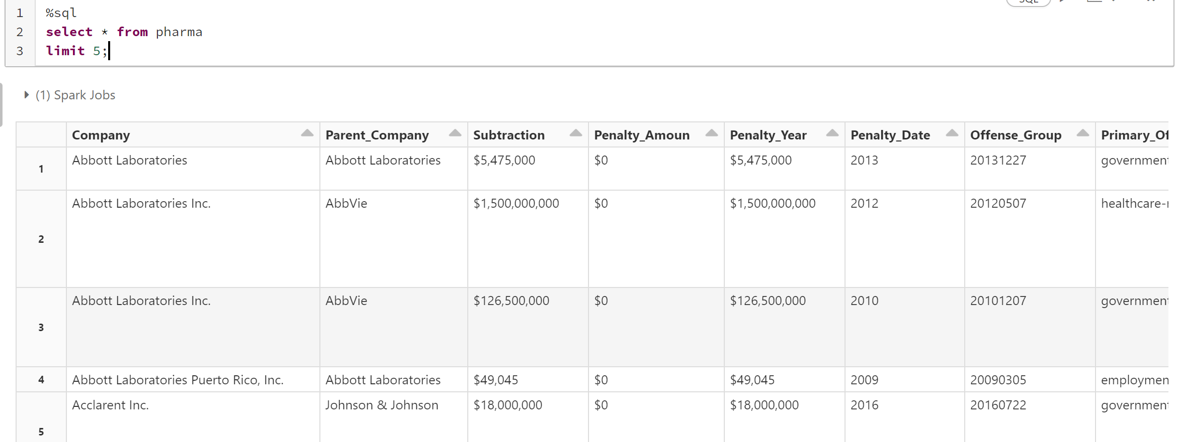

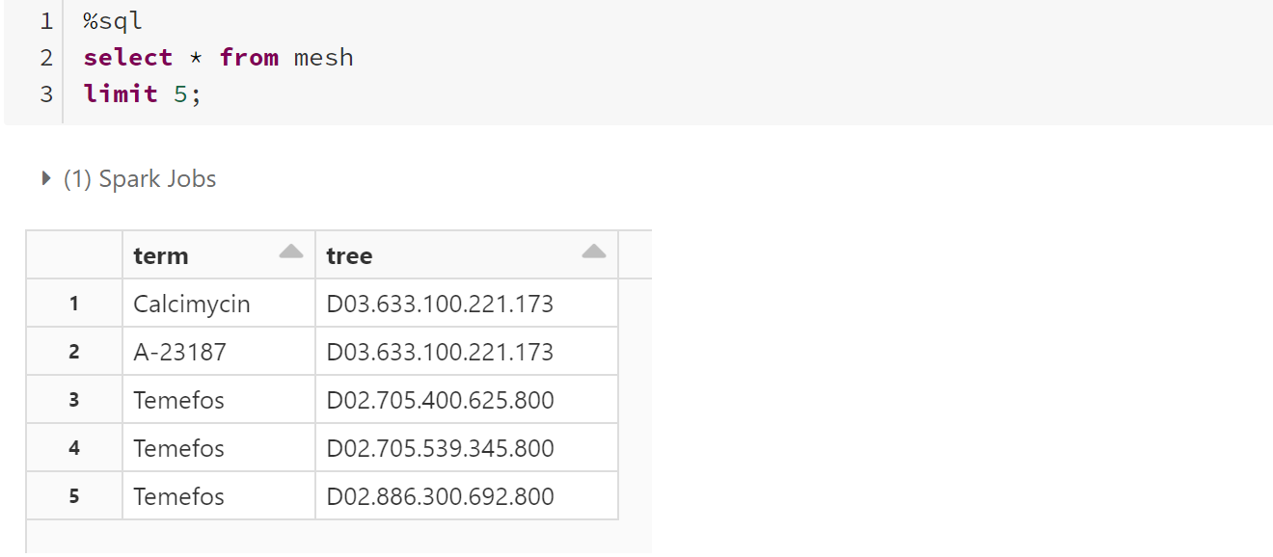

**3.0 DATAFRAME LOAD/DATA PROCESSING/SETUP**

Data frame is a distributed collection of data grouped into named columns.it is equivalent to a relational database in Spark SQL and can be created using various functions in Spark Session. Once created it can be manipulated using various domain-specific-knowledge (DSL) defined in data frame column.

In this task I will be using data frame to perform common data operations such as filtering and aggregation, as well as data analysis on large collection on distributed data. It provides a programmatic interface to interact with structured data stored as tables or views in a database from Spark application.

**3.1 Description of setup required for DATAFRAME in Pyspark(Databricks)**

Some libraries were setup to enable running of the required functions for proper implementation in PySpark Session.

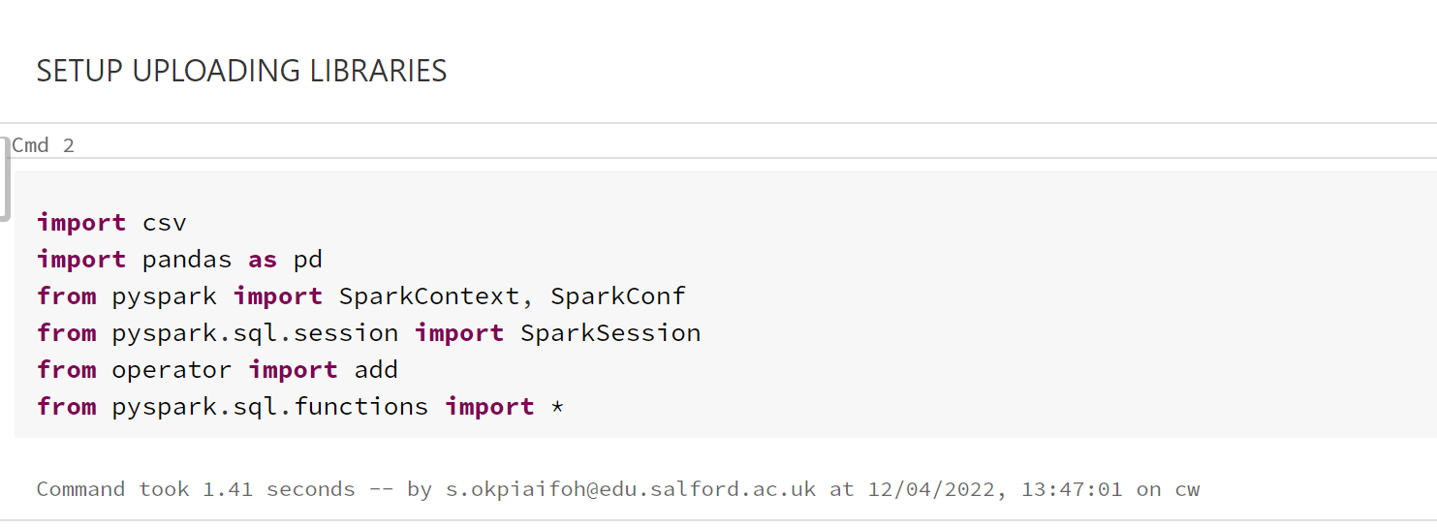

**3.2 Loading Data**

The below data was uploaded from blackboard to databricks "/FileStore/tables/" and renamed

**Data inspection to see if it exits** as follows

1. Clinicaltrial_2021
2. Pharma
3. mesh

checking FileStore to see the file

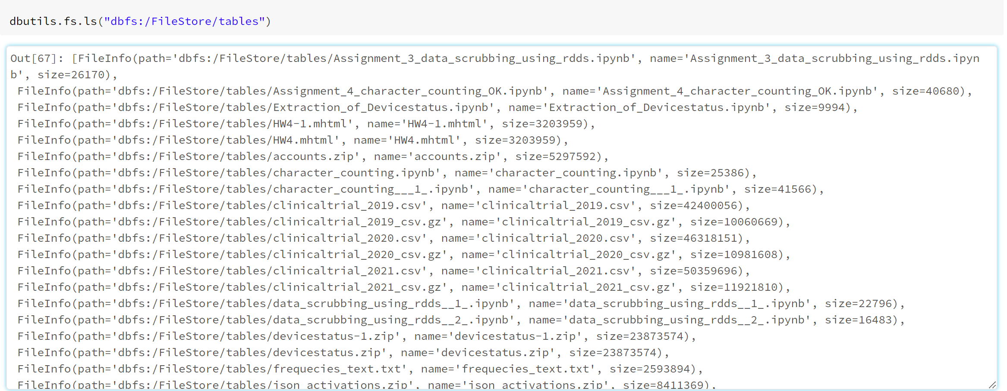

Data exploration header to see the delimiters and properties of the data to enable me to know a delimiter to use to separate, when importing data to notebook for analysis.

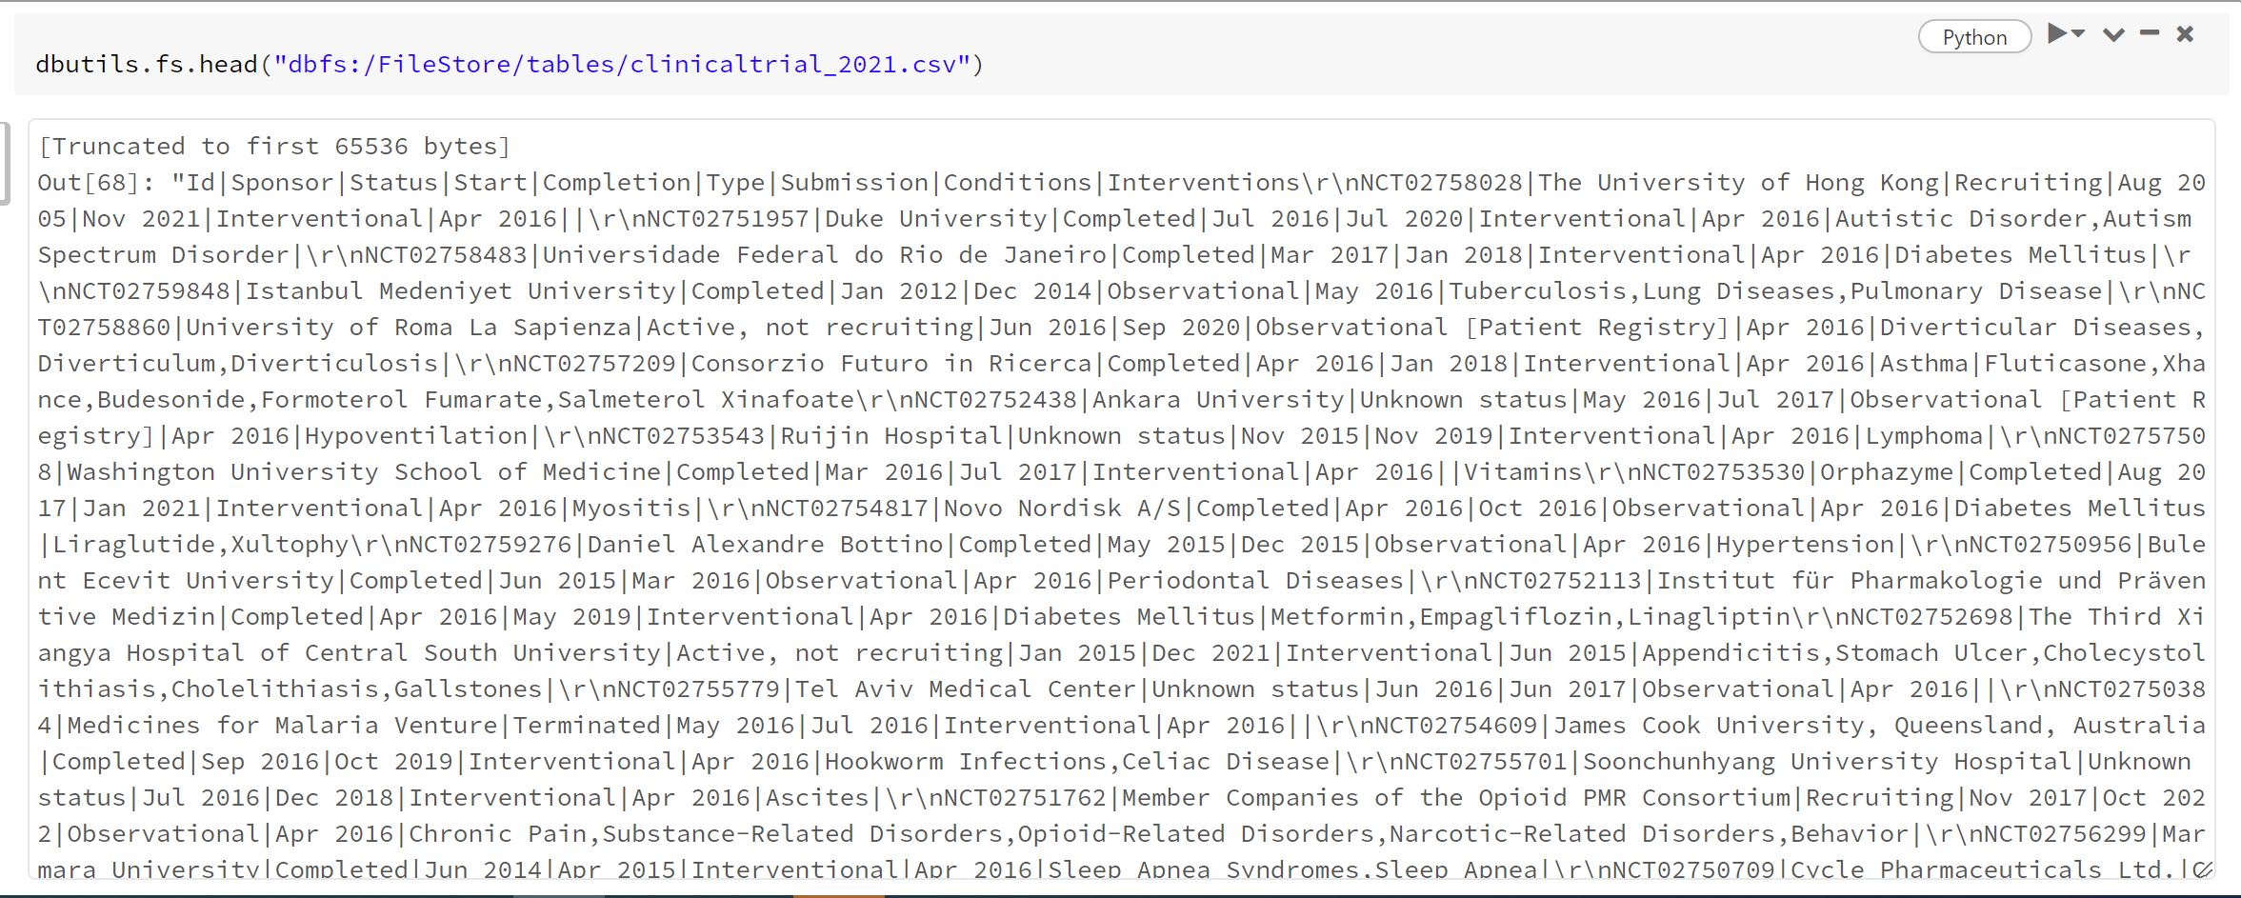

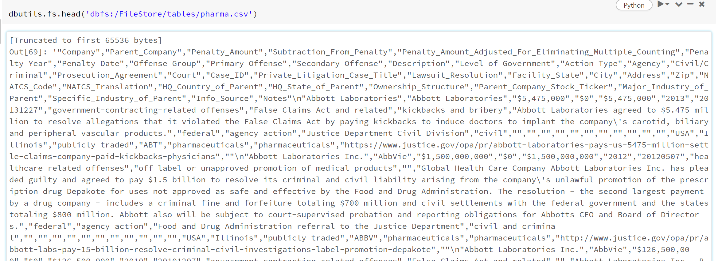

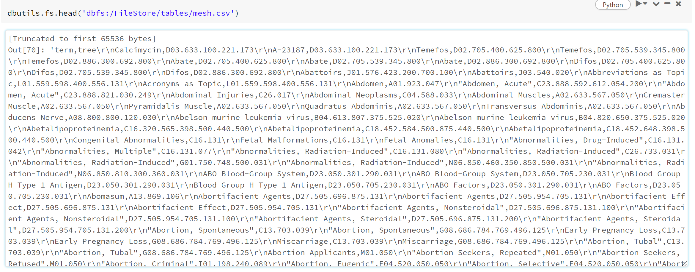

**3.3 Importing data:**

The data was set in import os environment it enables it to be reproducible by just changing the versions as shown below. There is a need to move the data using databricks utilities (dbutils.fs.cp) to copy the file to /tmp/ for temporary storage. This to unzip the file in shell command.

Different file location was assigned to the file’s storage for reproducibility as show below

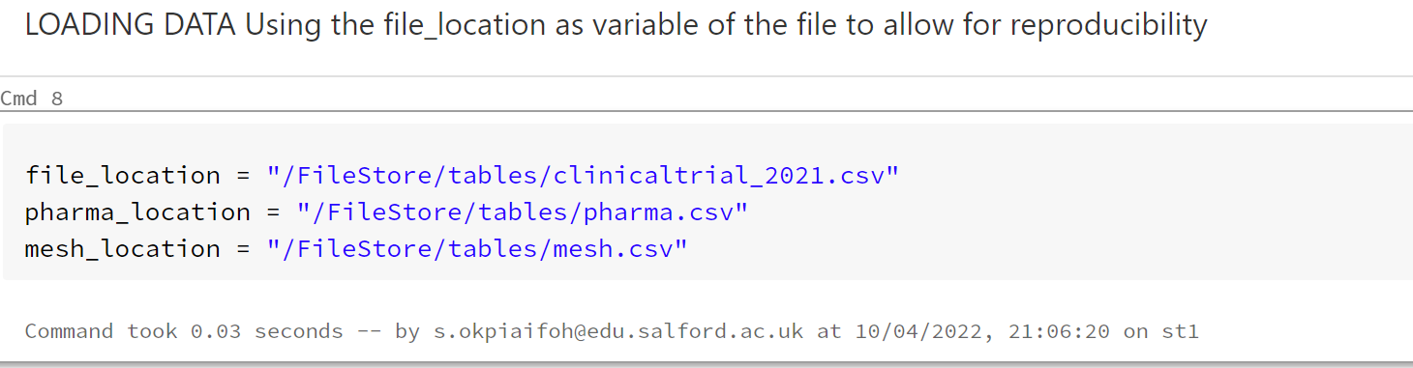

From the display of the head of the data, it was observed the clinical trial data was separated by a pipe delimiter, so in that case pipe was used as delimiter to upload to databricks notebook while the Pharma and mesh data remains as comma separated delimiter.

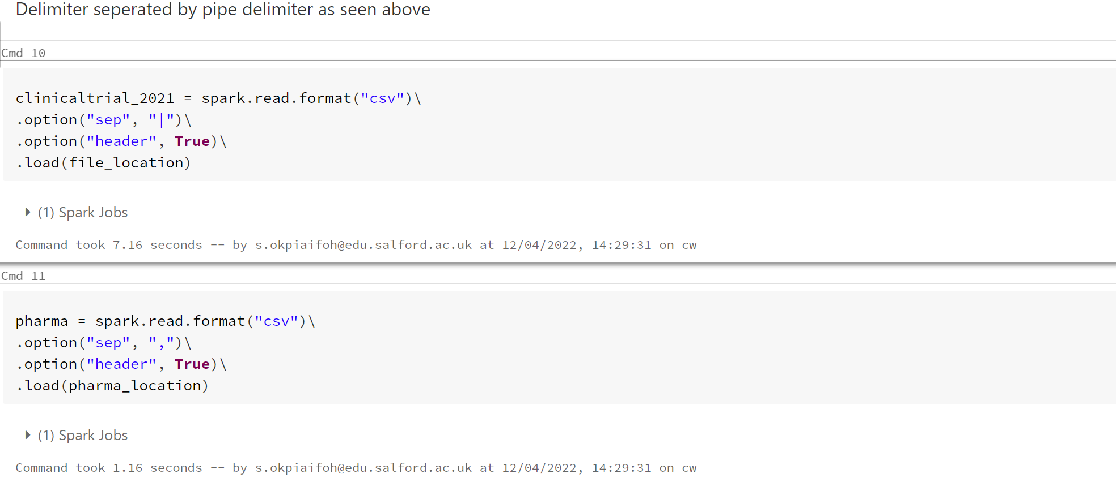

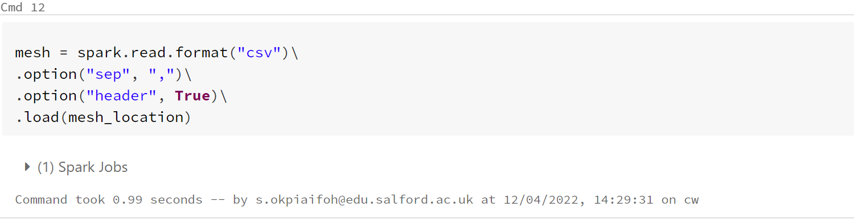

The stage now is to view the schema on each file uploaded to understand the structure in the table, this displays the data type the columns and constraints on the table.

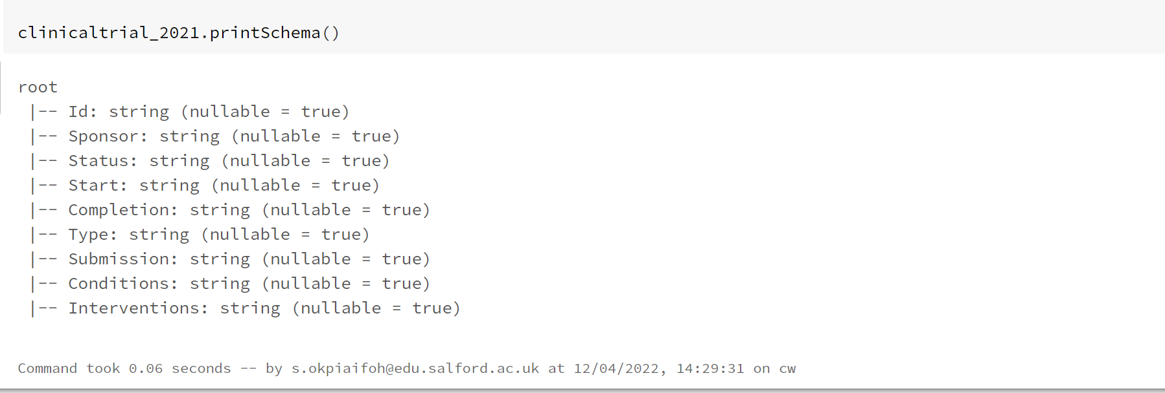

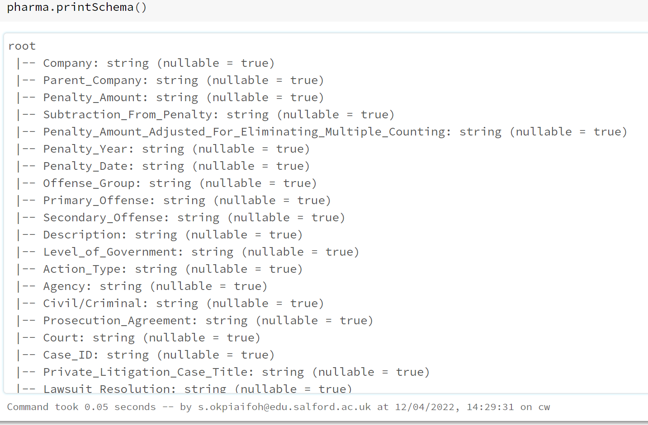

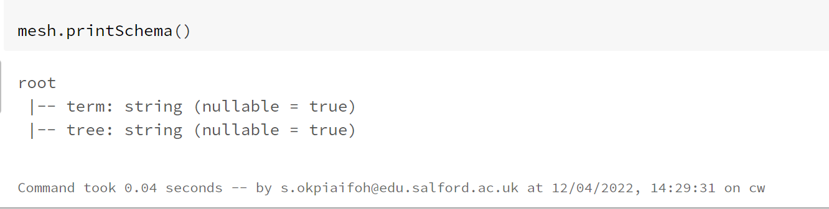

As a process of data pre-processing viewing the columns to understand the business questions and methods to solve these questions.

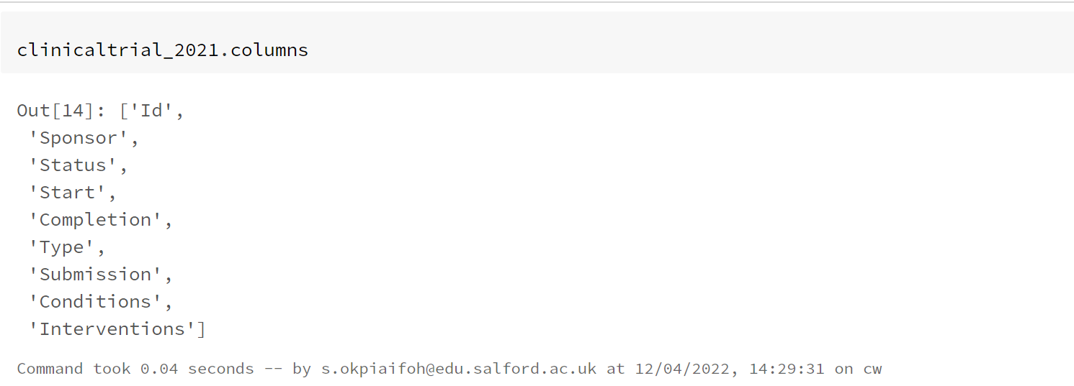

**QUESTION 1 RDD**

ASSUMPTION:

1. One specific thing to watch out for is missing data or place-holder value
2. dataset is separated by pipe value.
3. I tend to assume that all fields in the data contains usable value and no blank space.

RDD implementation outline: the number of studies in dataset is going to count using the pySpark count function.

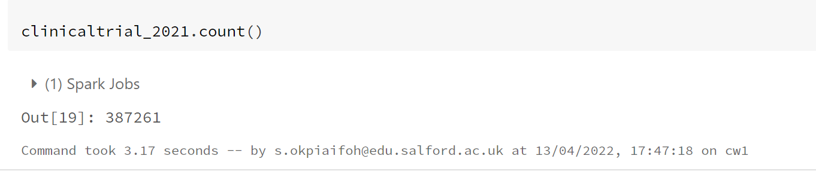

**QUESTION 1 HIVEQL**

**ASSUMPTION:**

1. it is assumed that the notebook is in SQL language
2. It is assumed that the dataset is normally distributed across the entire table
3. It is assumed that the dataset is uploaded, and pipe separated.
4. Header set to true to avoid distinct studies been counted.

**IMPLEMENTATION:**

1. Load data in programmatically with a reusable code
2. Data examined and check for any missing data
3. Select count statements performed on the entire clinicaltrial dataset.

Data imported from FileStore.

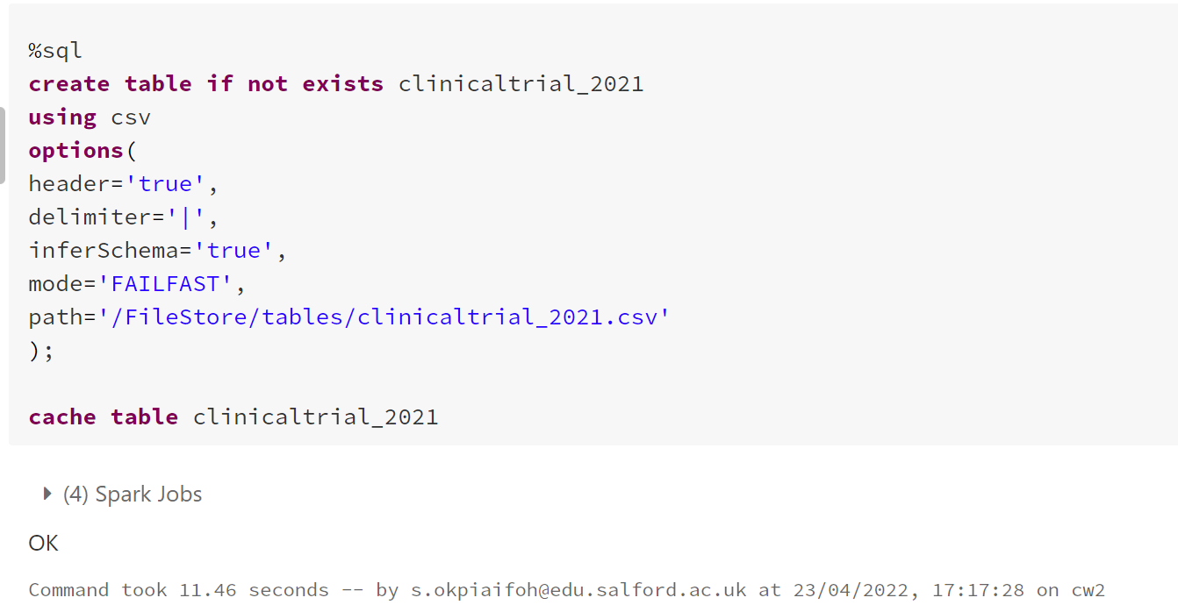

First five records displayed

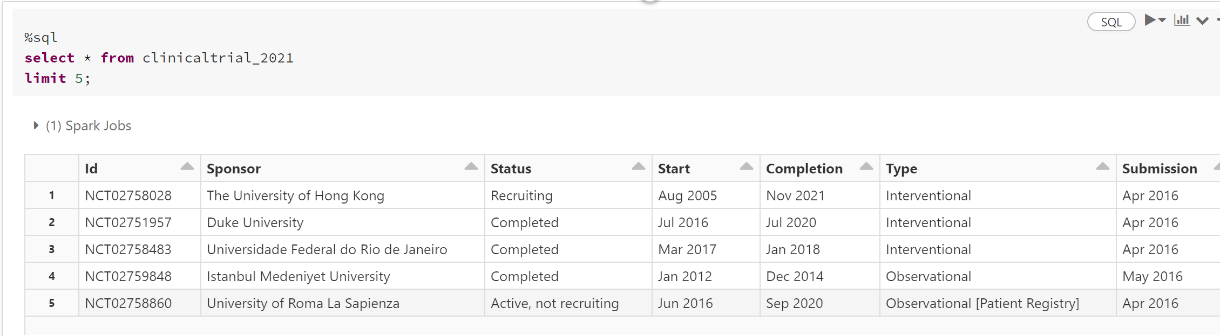

Counting function performed below to count the number of studies in the dataset.

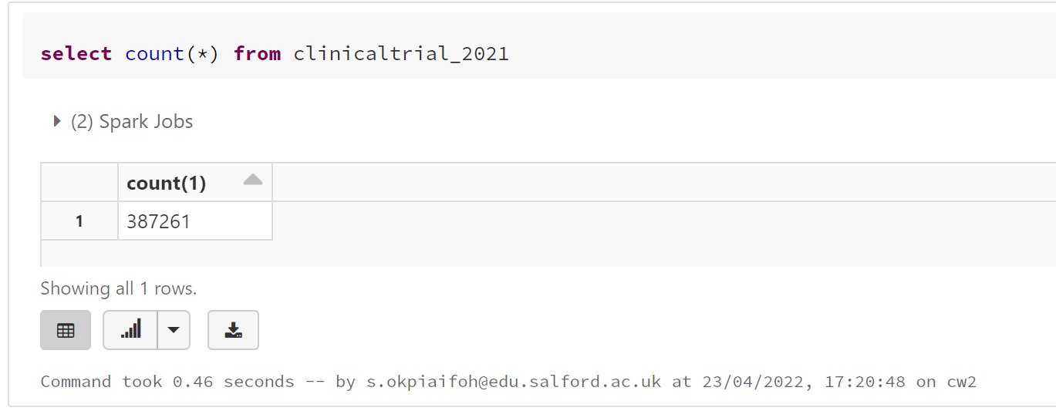

**QUESTION 1 DATAFRAME**

Assumption:

1. It is assumed that header is true
2. All records in the dataframe are usable and does not contain any blank space
3. All records are evenly distributed and can be split in partitions.

Implementation outline:

1. Basically, count function was used to count the number of elements in clinicaltrial 2021,this count operation will aggregate all the rows in the data frame as shown below

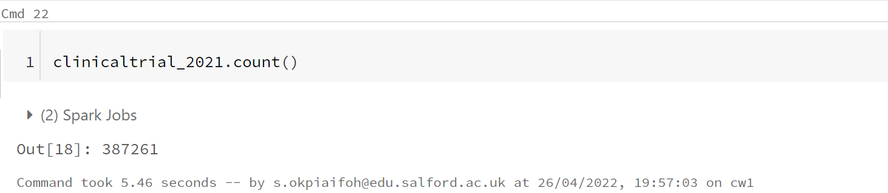

**QUESTION 2 RDD**

Assumption made:

1. Beyond all doubt Conditions is assumed to be on index seven
2. Sponsor on index one.
3. It was assumed that column Type on index five.

Implementation outline:

listing all the studies the Type Column and their frequencies, Type by indexing is in the fifth column, so I ran Type to be 5,filter out spaces in the column with the filter function, then apply map function ,reduceByKey with add function and sort by key with ascending as false.

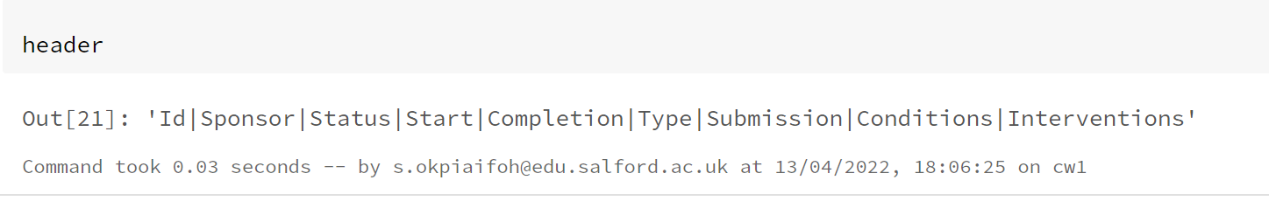

Above code showing Type is in column 6 and index five

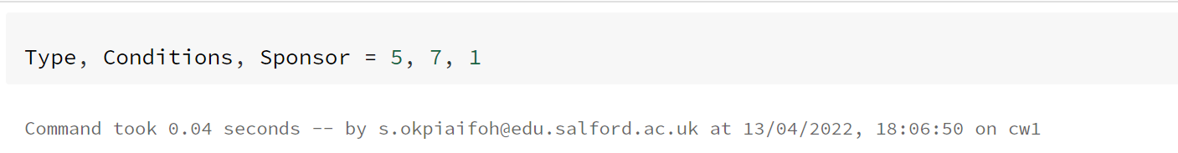

Above code was called to tell the system where Type, Conditions and Sponsor belongs in the dataset.

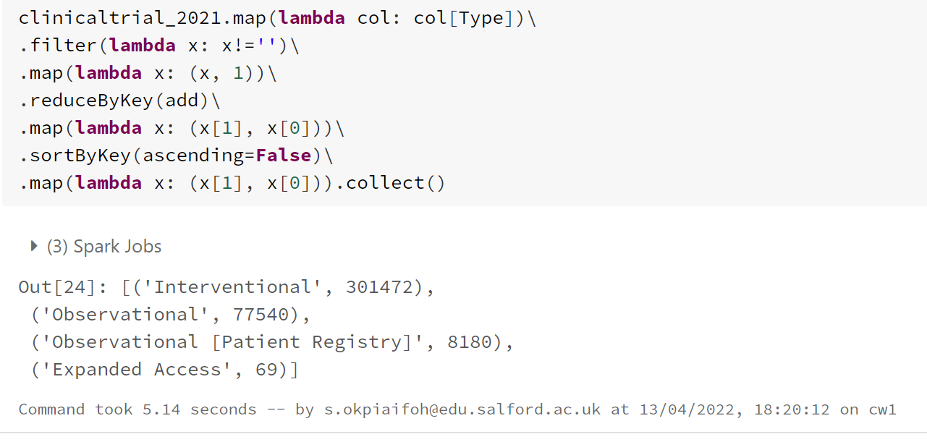

**QUESTION 2 HIVEQL**

Assumption: the column of interest is Type; I assume no null value exist in the record of “Type”

Implementation:

1. A select statement with all clauses was used to filter Type and alias as frequency
2. Filtering applied to filter and remove record that are not null.
3. Then grouped by Type and order by frequency in descending order.

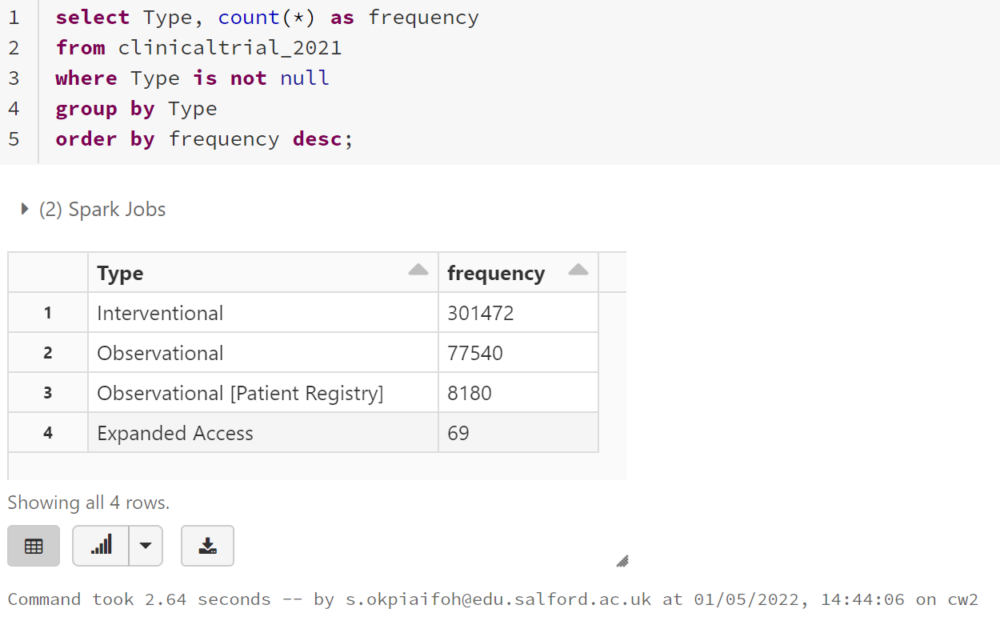

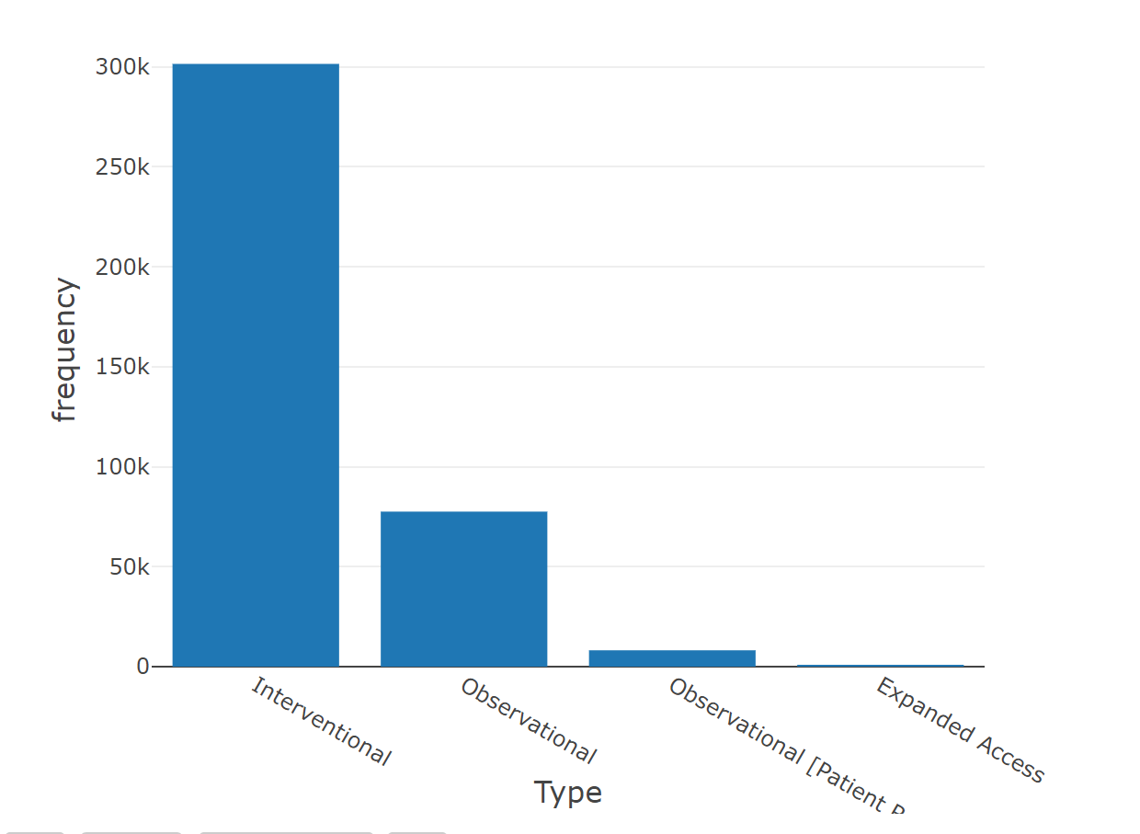

Bar plot of TYPE against FREQUENCY.

**QUESTION 2 DATAFRAME**

Assumption:

1. Question two involve group by clause so I have checked the infer schema to see the datatype for the Type column is nullable
2. The Type column should be aggregated

Implementation outline:

1. I must go over all the columns of clinicaltrial_ 2021 and count
2. Then apply when function to type to select out only the column that has type.
3. Then I use order by count ascending as shown below

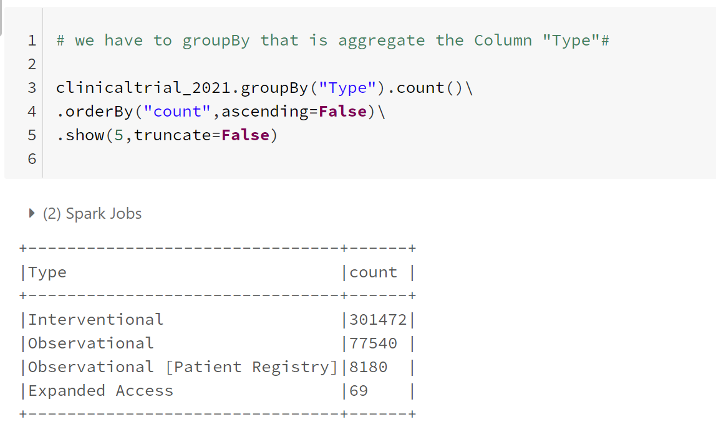

**QUESTION 3 HIVEQL**

Assumption:

1. Assumed conditions in the eight column and index seven
2. The record in Conditions(disease) column separated by comma

Implementation:

1. A column called new_conditions created and explode function used to separate the conditions and split by comma.
2. The new column counted alias as frequency
3. Group by new_condition
4. Oder by frequency

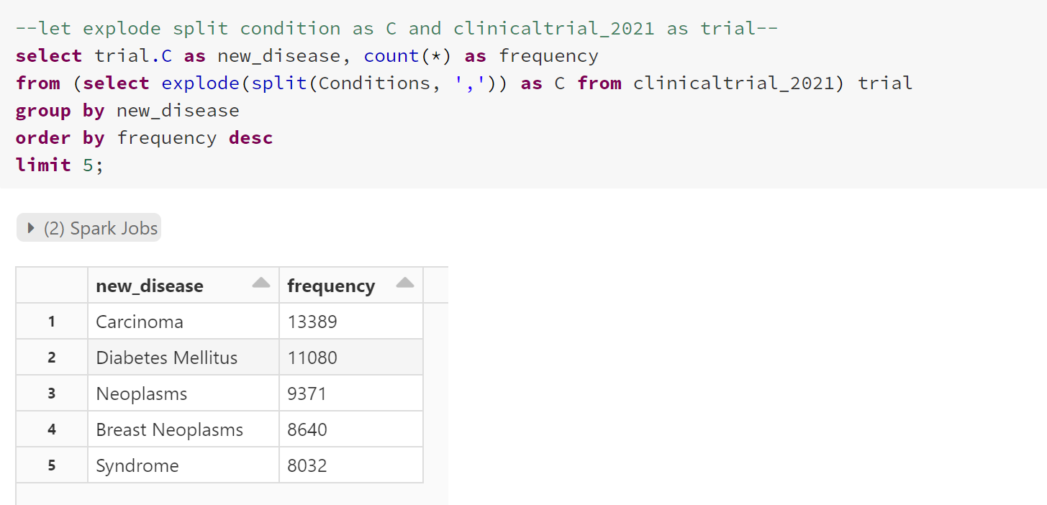

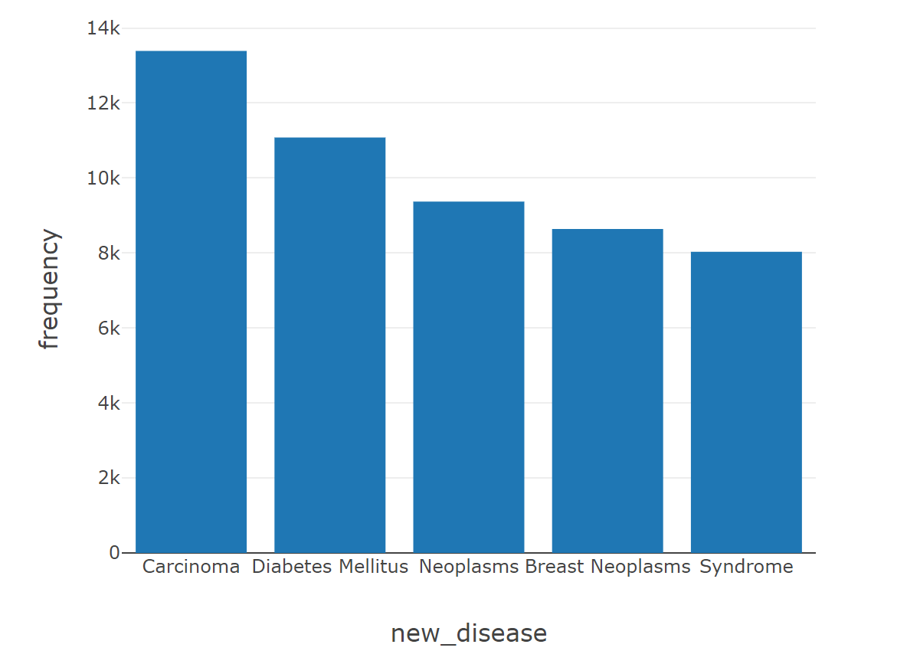

Bar chart of disease against frequency

**QUESTION 3 RDD**

**Assumption**:

1. it was assumed that conditions are on seventh index column of the data set.
2. Also assumed the study might contain more than one observation i.e., conditions.

**Implementation outline**:

1. filter function to remove missing data
2. apply map function and split by comma
3. flat map to flatten the dataset
4. Reduce by key and filter again
5. Sort by ascending = false and take 5 conditions

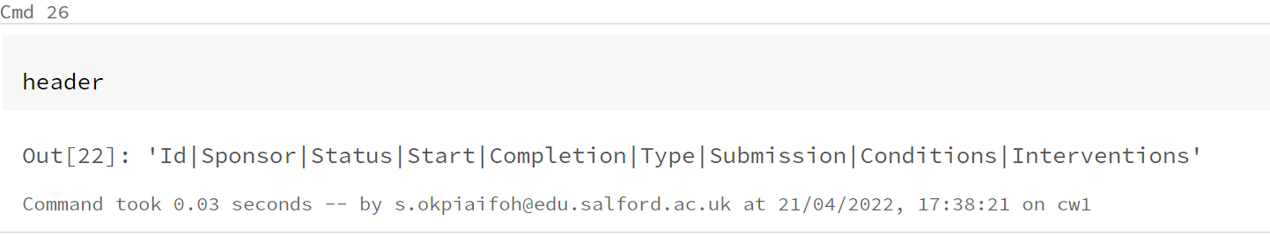

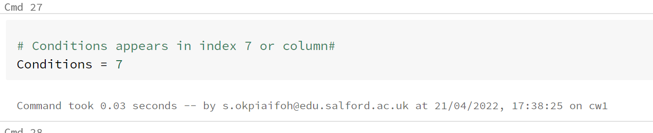

Conditions as seen above appears in column 8 and index seven so running a code to call the index in the dataset.

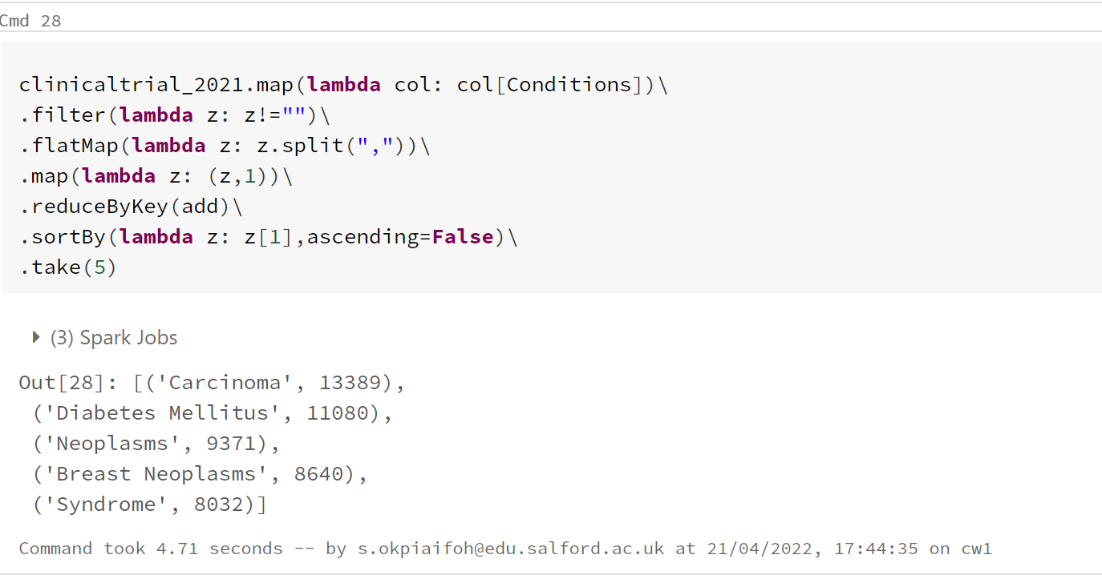

**QUESTION 3 DATAFRAME**

Assumption:

1. Based on this question, it is basically separated by pipe (|), so I have to split by comma.
2. The data conditions column contains null values, so it is assumed we need to drop it
3. Assumed conditions is on7th index in the data frame.

Implementation outline:

1. Must view the data to see the null values in conditions
2. Drop the null values using the drop.na function and split by comma
3. Use explode function on conditions and rename the column to new_conditions
4. Drop conditions column, group by the new column and sort by count

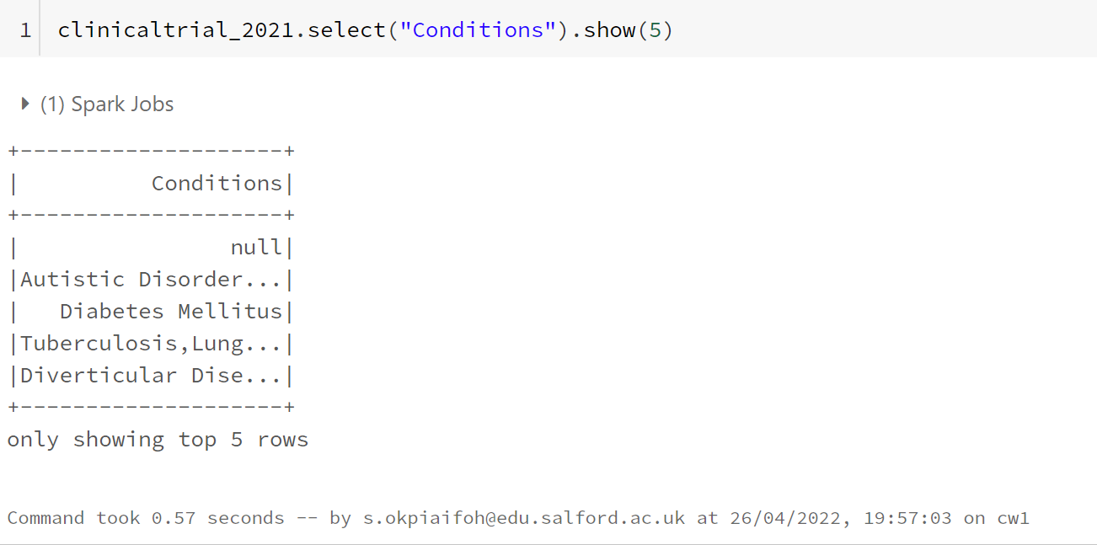

Null values in conditions show above, the below code will drop it.

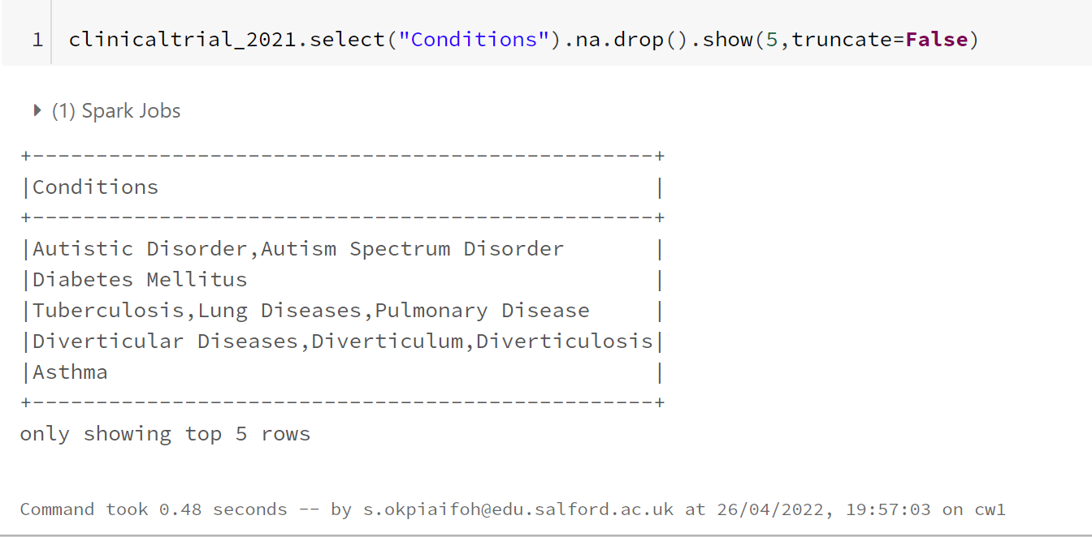

Null values dropped as shown above.

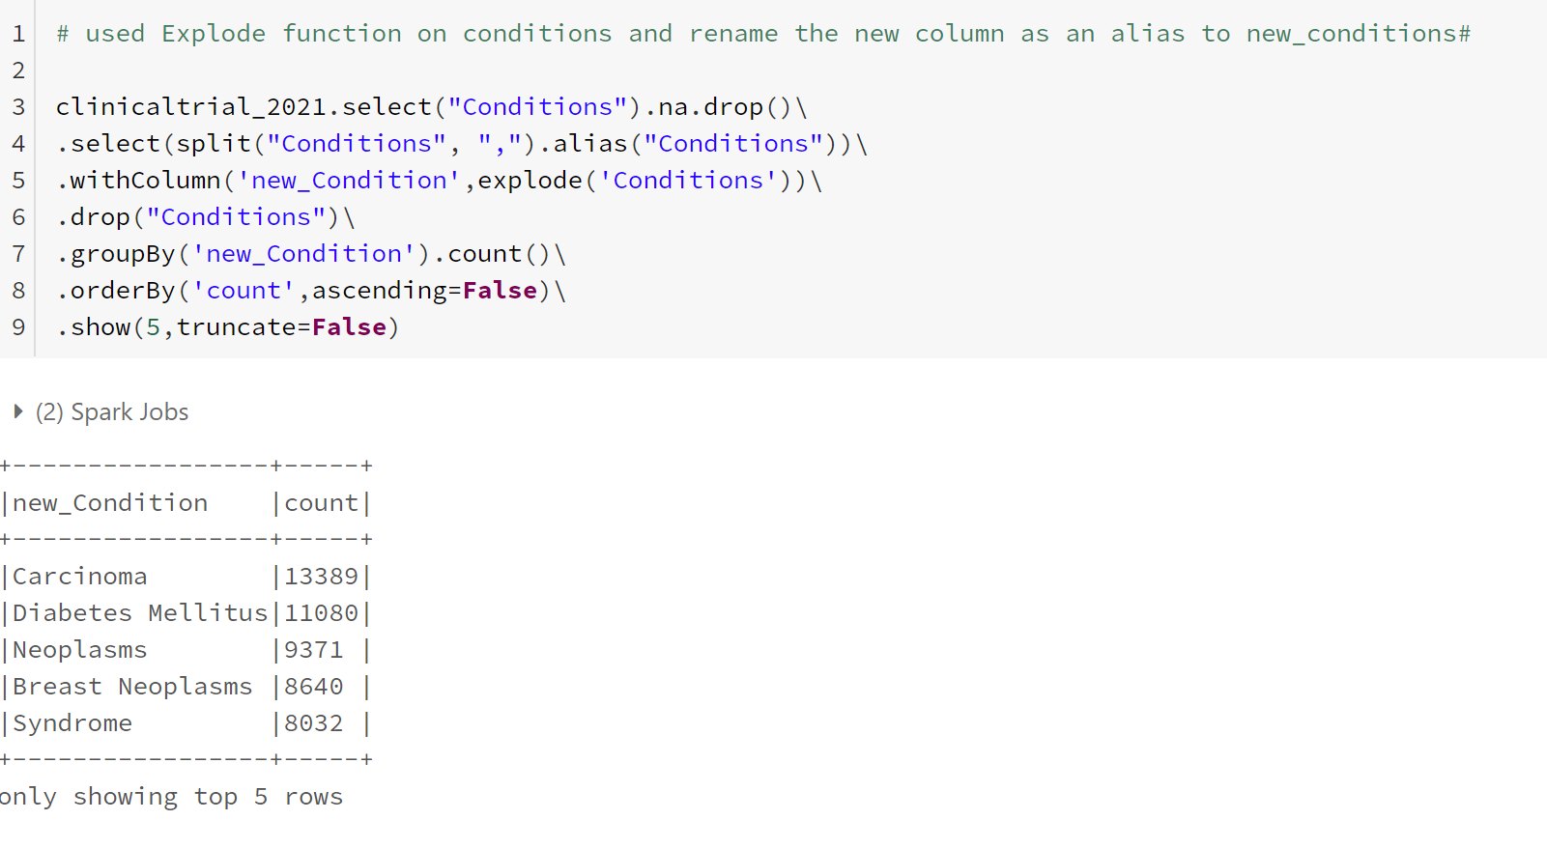

**QUESTION 4 RDD**

**ASSUMPTION:**

Variable name final RDD assigned to clinicaltrial 2021 (which is filtered from previously in question 3)

**IMPLEMENTATION OUTLINE:**

1. Final RDD called up
2. Mesh pair created from mesh RDD
3. Final RDD joined using the join function with the mesh pair
4. Filtering, map, sort by and reduce by key function applied

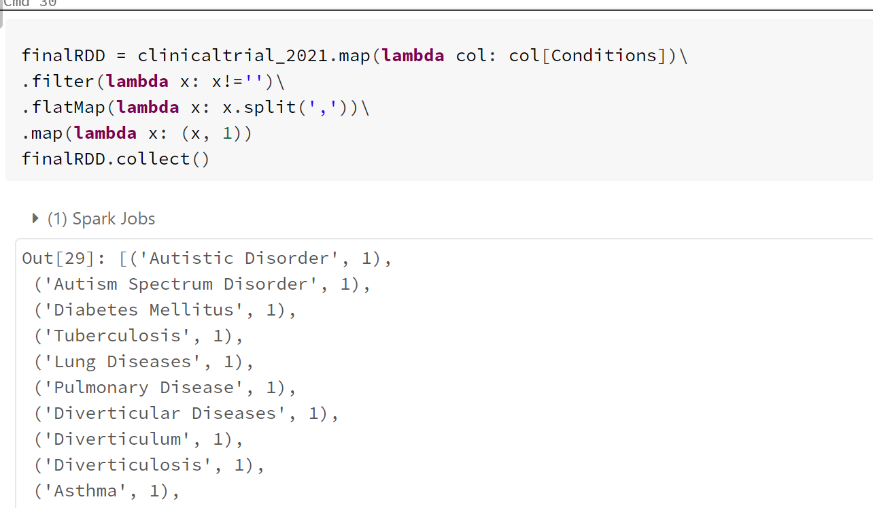

**Variable final RDD assigned as above code**

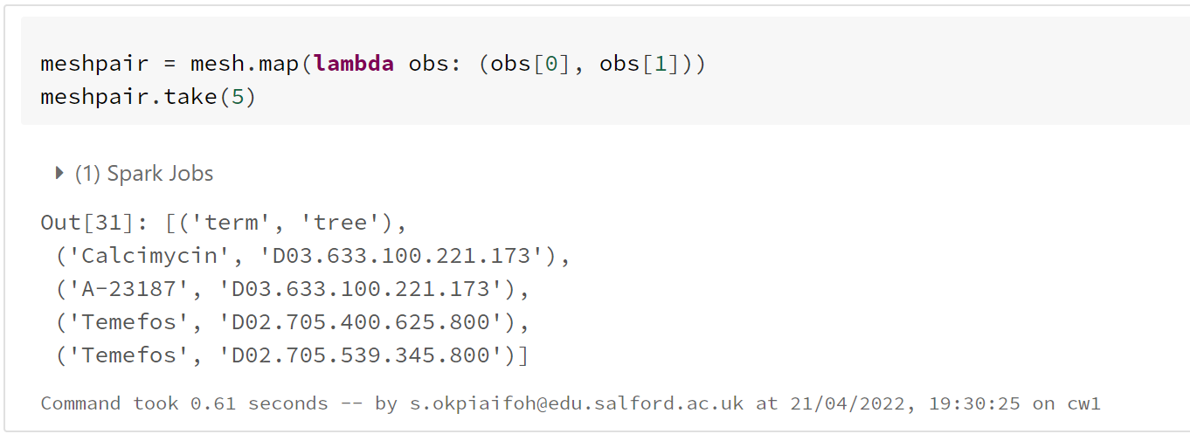

**Above code with mesh pair showing column for term and tree from mesh RDD.**

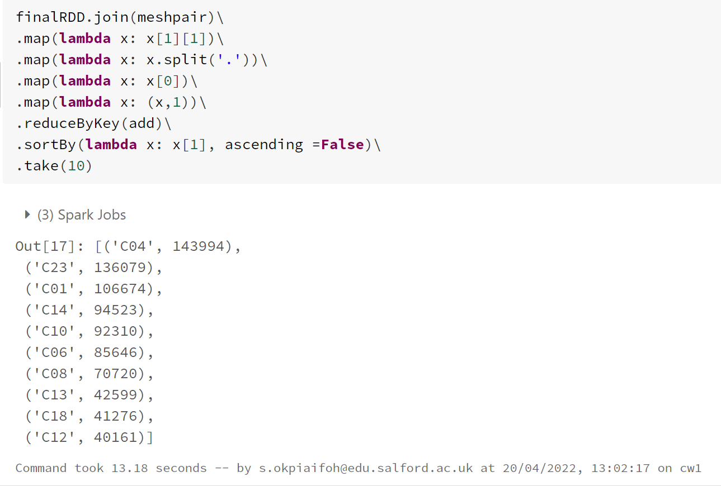

**Above code shows final RDD joined to mesh pair showing the five most frequent root**

**QUESTION 4 HIVEQL**

Assumption:

1. Disease is in Conditions column
2. Assumed from mesh data, the tree column contains the hierarchy codes separated by dot.
3. The idea is to extract the code from tree record and match it with disease conditions from clinicaltrial 2021.

Implementation

1. A view was created with a select statement called disease from exploded conditions separated by comma from question 3 and clinicaltrial data 2021.
2. Using select statement to select the third index in the code and count alias frequency
3. Using where clause to filter a combination of codes from tree column to disease
4. Grouping by code and order by frequency.

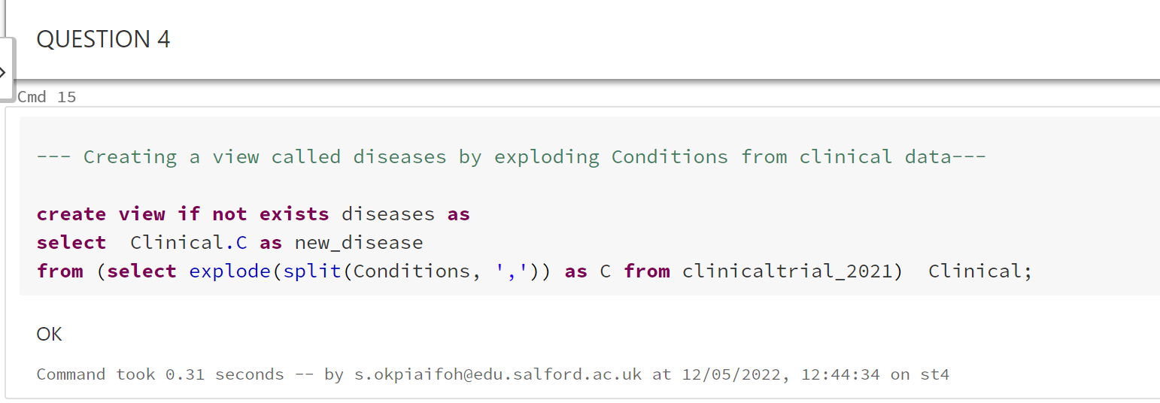

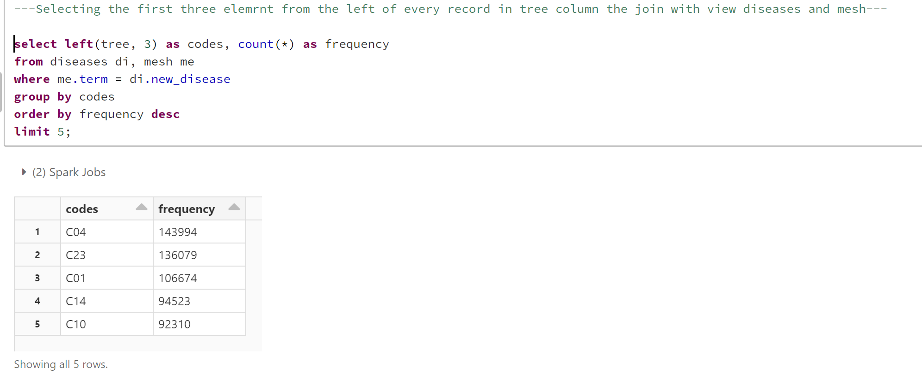

**QUESTION 4 DATAFRAME**

Assumption made:

1. Null and space in the record (Conditions) observed, so I have to use drop function
2. It is assumed that the mesh dataset contains usable records and not null or blank space.
3. It is assumed that tree column from mesh dataset will be joined to Conditions from the clinicaltrial 2021.

Implementation:

1. The code result from question 3 assigned to disease, a variable name called disease created
2. The mesh data examined, show first five rows
3. A join clause used to join the mesh data with the clinicaltrial 2021 and examined

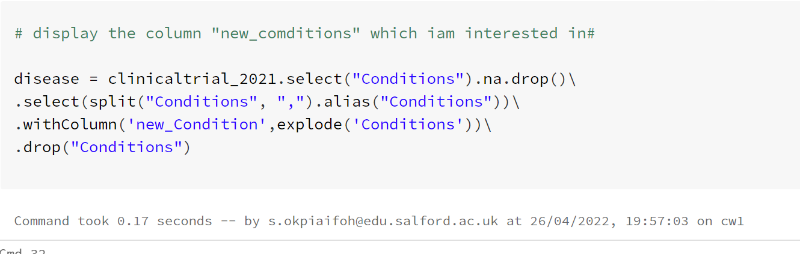

Variable called disease created above.

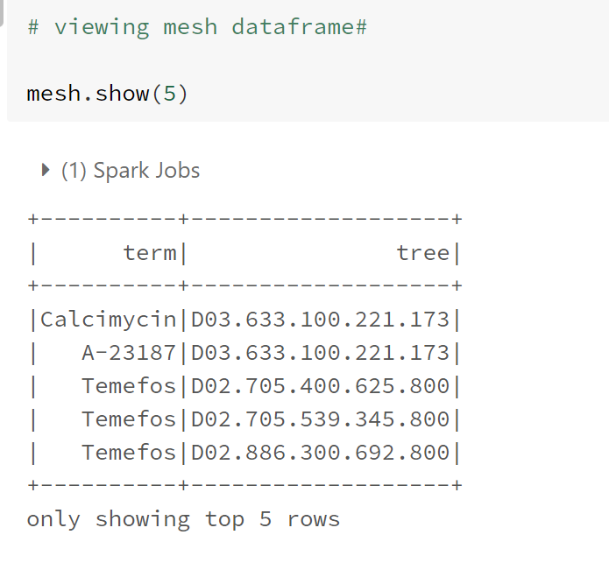

Mesh data view above

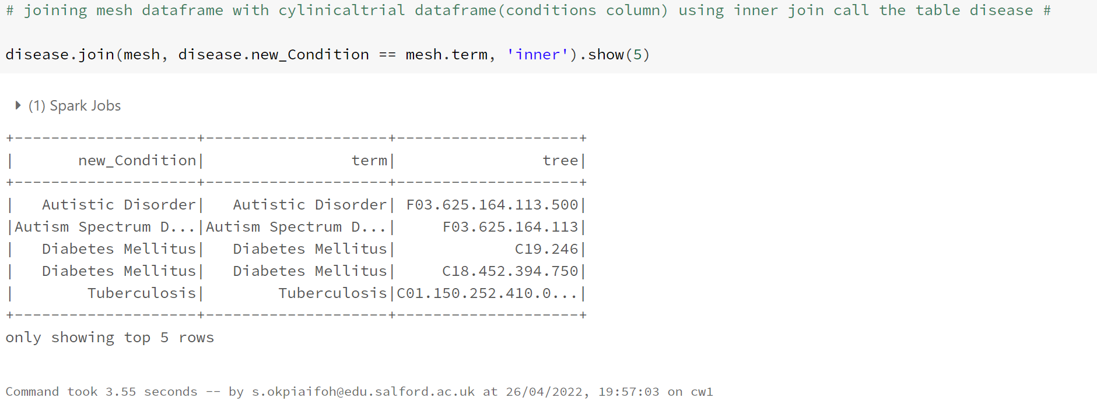

Join clause joining mesh data to clinicaltrial 2021 data set with code above.

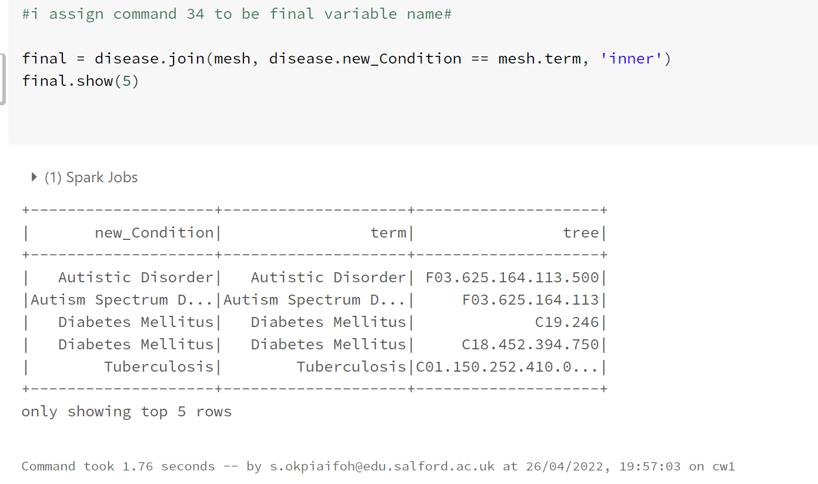

Another variable name created called final, which is the join clause statement.

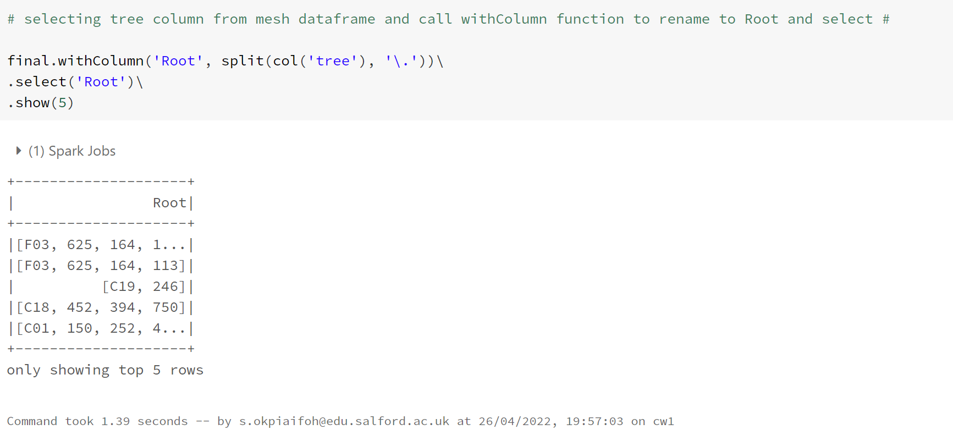

This code used to extract tree column from mesh data, then used withColumn function to rename to Root.

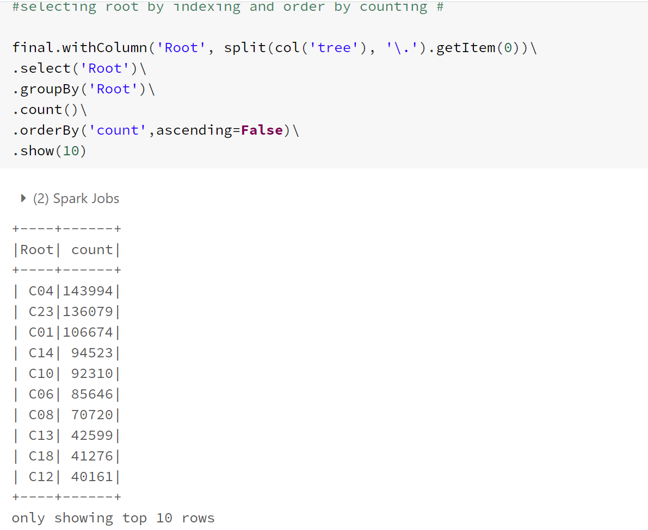

Final code selecting root by indexing and order by count.

**QUESTION 5 RDD**

**ASSUMPTION:**

1. It assumed that the pharma dataset is evenly distributed and of usable value.
2. It assumed that the Sponsor column is in index one and parent company is also in index one.
3. A variable name called sponsor_RDD assigned to clinicaltrial 2021 merged with pharma dataset using broadcast function.

**IMPLEMENTATION:**

1. Pharma dataset called in RDD; header filtered to remove unwanted count.
2. Map function with strip applied on sponsor RDD to remove punctuations.
3. Map values function created to separate the dataset into values.

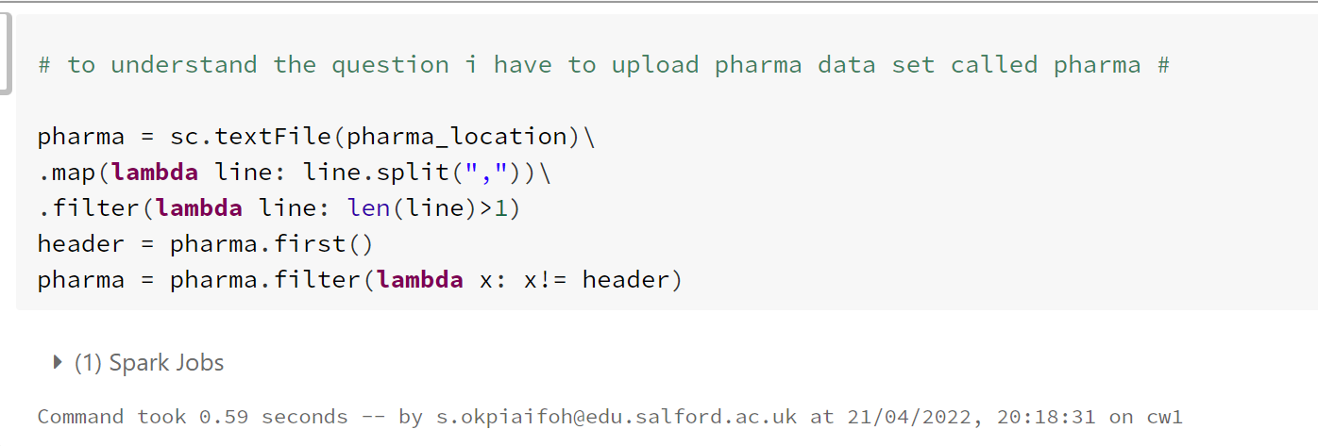

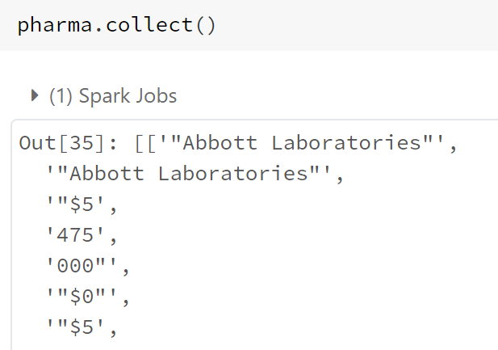

**Map function with strip function will remove the punctuation in above collect display**

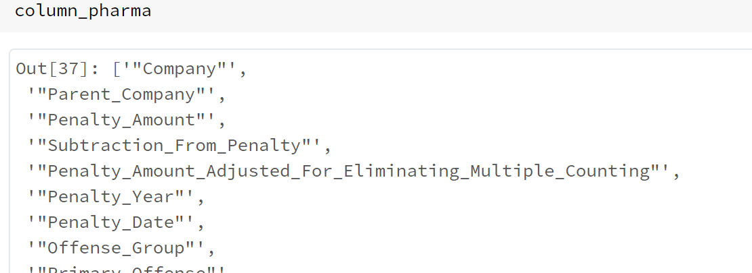

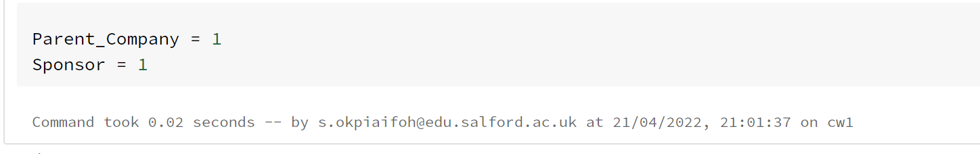

Above code indicate that parent company and sponsor appear in index one.

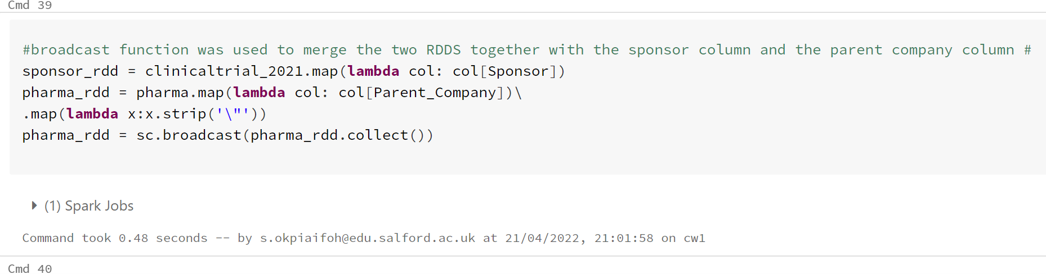

The code will strip out the unwanted punctuation, then filter sponsor RDD , map Value function and sort by as below.

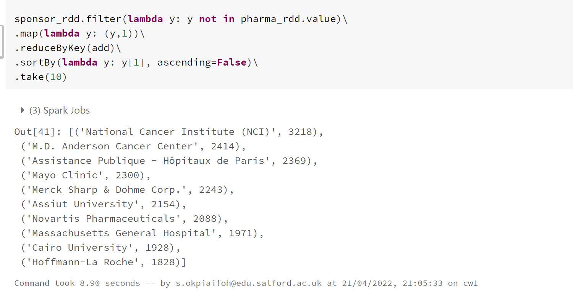

**QUESTION 5 HIVEQL**

Assumption:

1. It assumed that the parent company contains all possible records for pharmaceutical companies.
2. The question involves records from sponsor column on clinicaltrial data and parent company column from pharma data.
3. It assumed that the pharma data does not contain punctuation that would affect the records.

Implementation outline:

1. First step was to get the sponsor records from clinicaltrial 2021 data

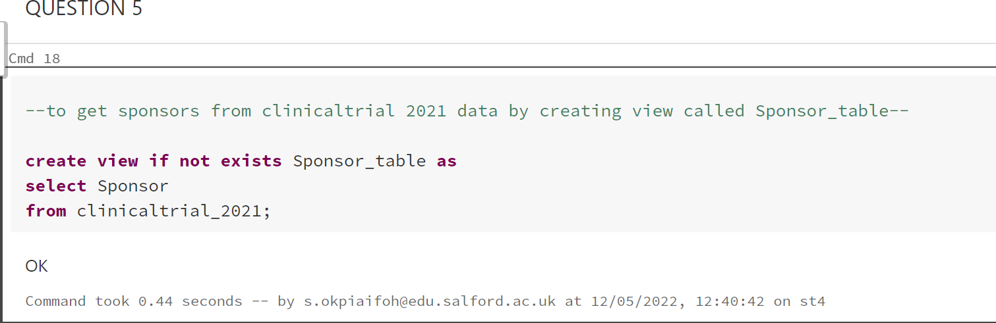

1. Create a view containing records of pharmaceutical companies from pharma

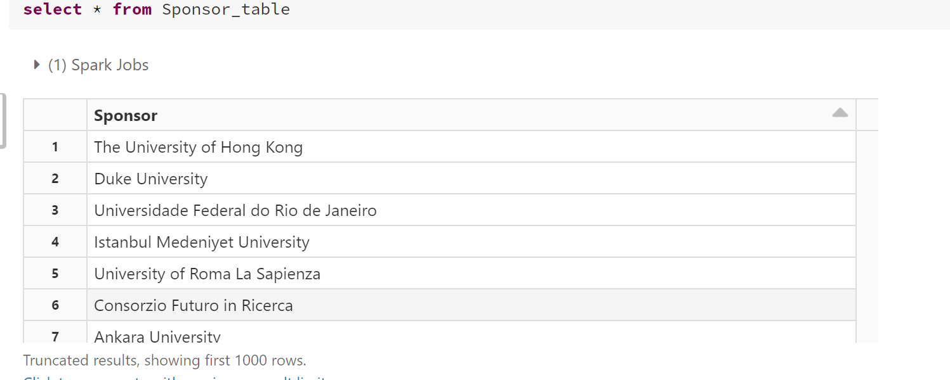

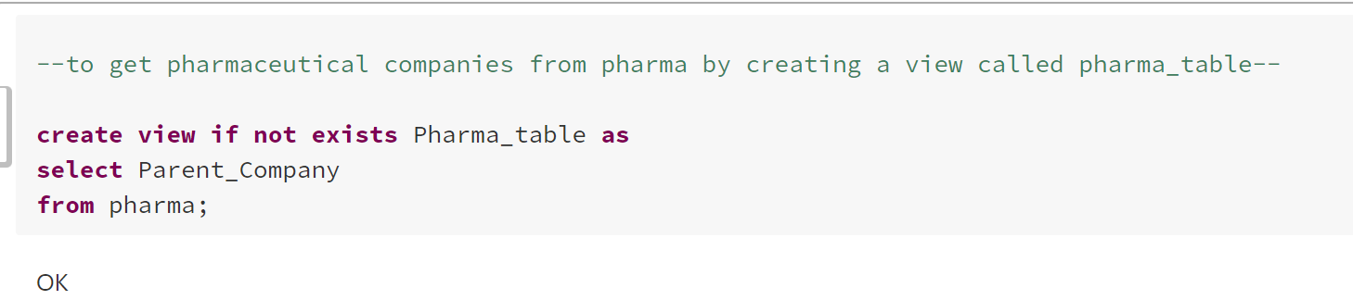

1. Select records that are not pharmaceutical records

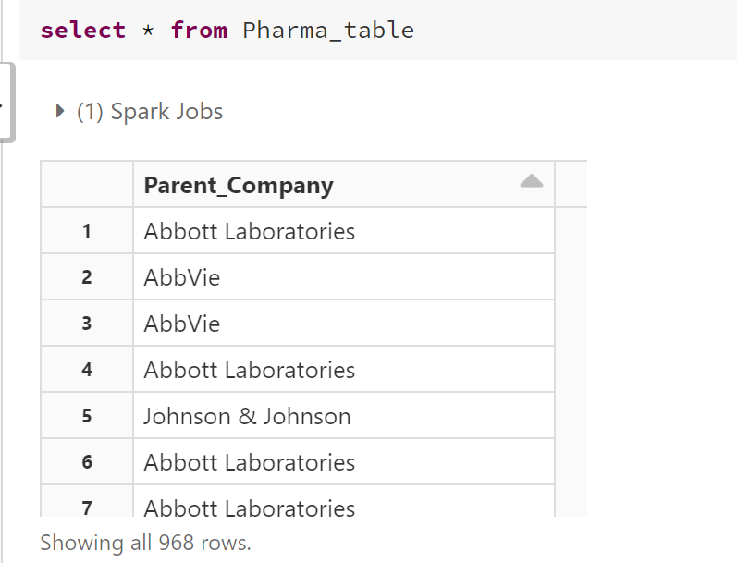

Display of Pharma_table with records of pharmaceutical companies only

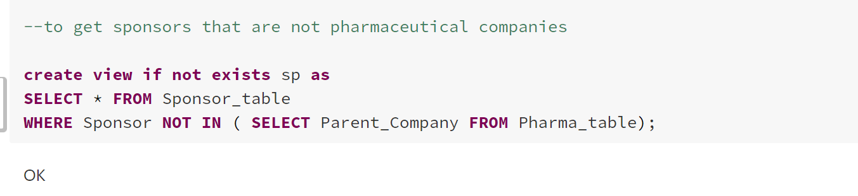

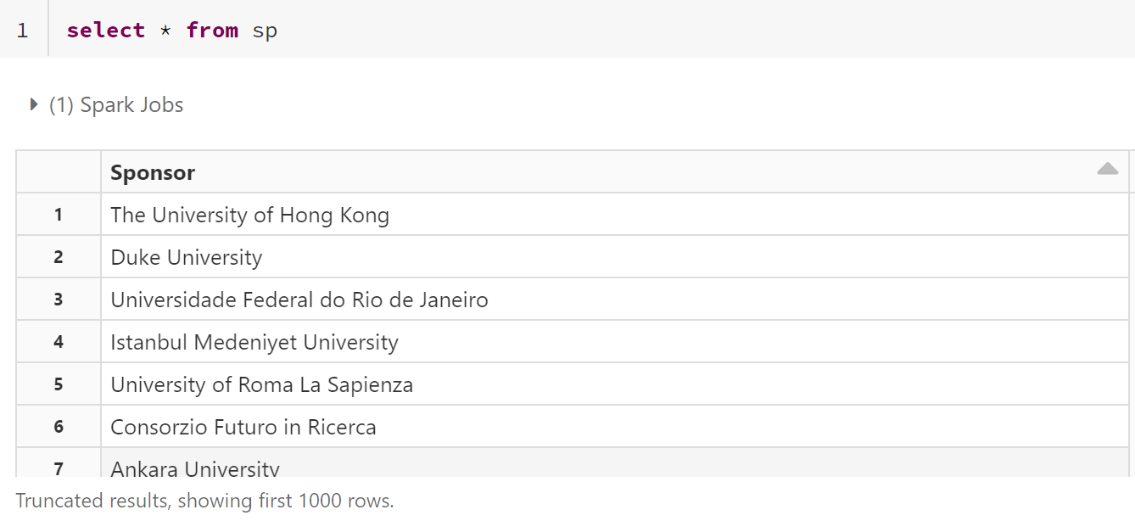

Table showing sponsors that are not pharmaceutical companies.

1. Finally select sponsor from stage 3 above counts alias as frequency where completion has no space, group by sponsor and order by frequency descending and limit to ten.

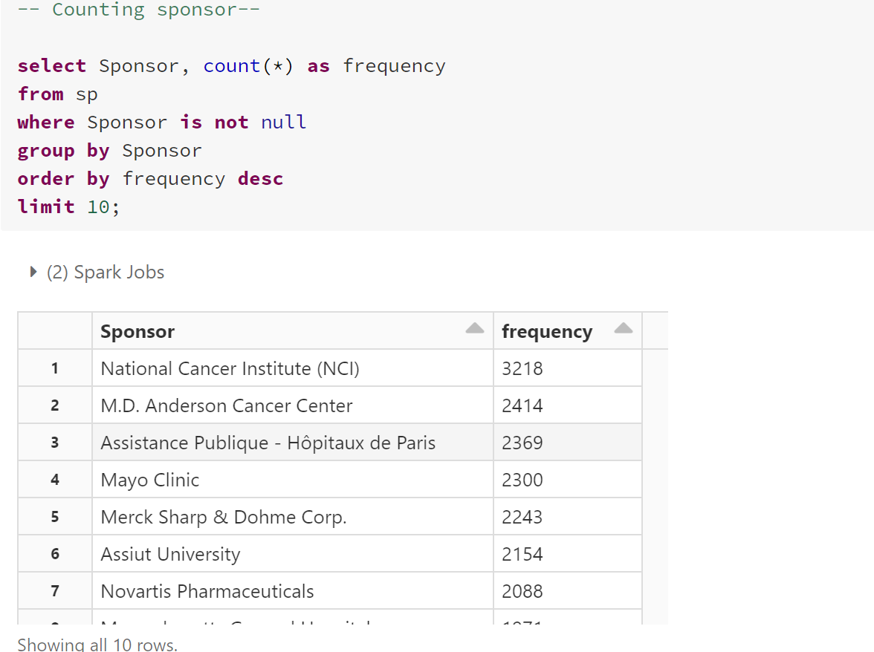

**QUESTION 5 DATAFRAME**

Assumption:

1. It assumed that the Parent Company column contains all possible pharmaceutical companies.

Implementation:

1. Used select clause to pick out Sponsor

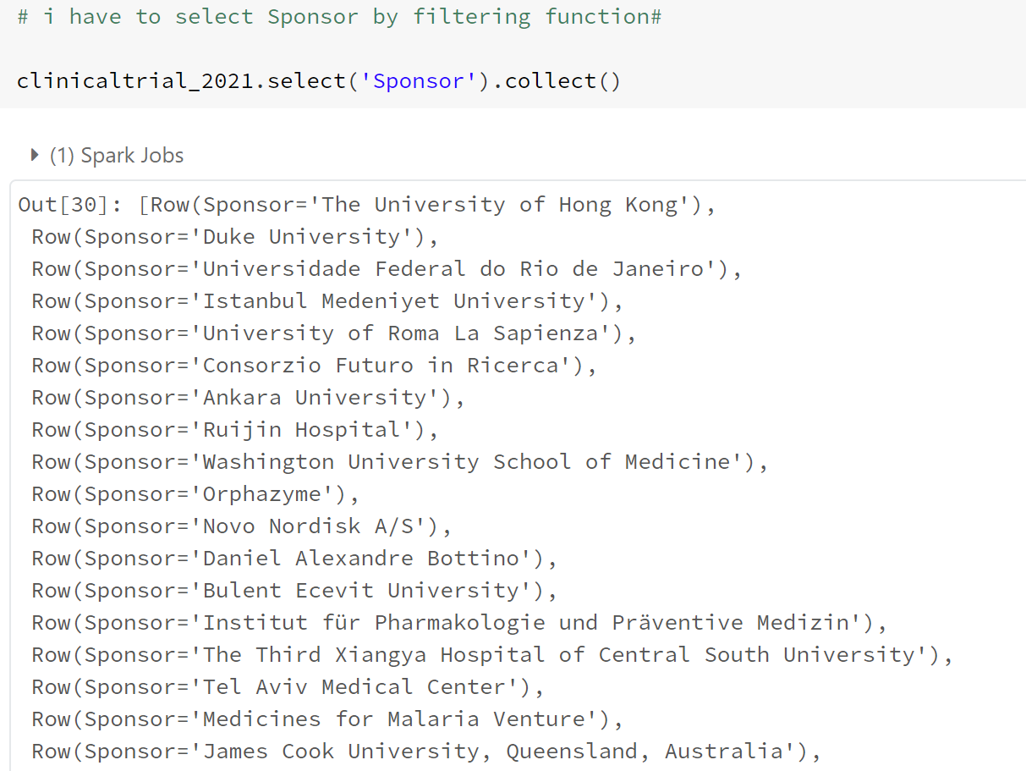

1. Statement to select parent company from pharma data to enable me to have a clear view of the column.

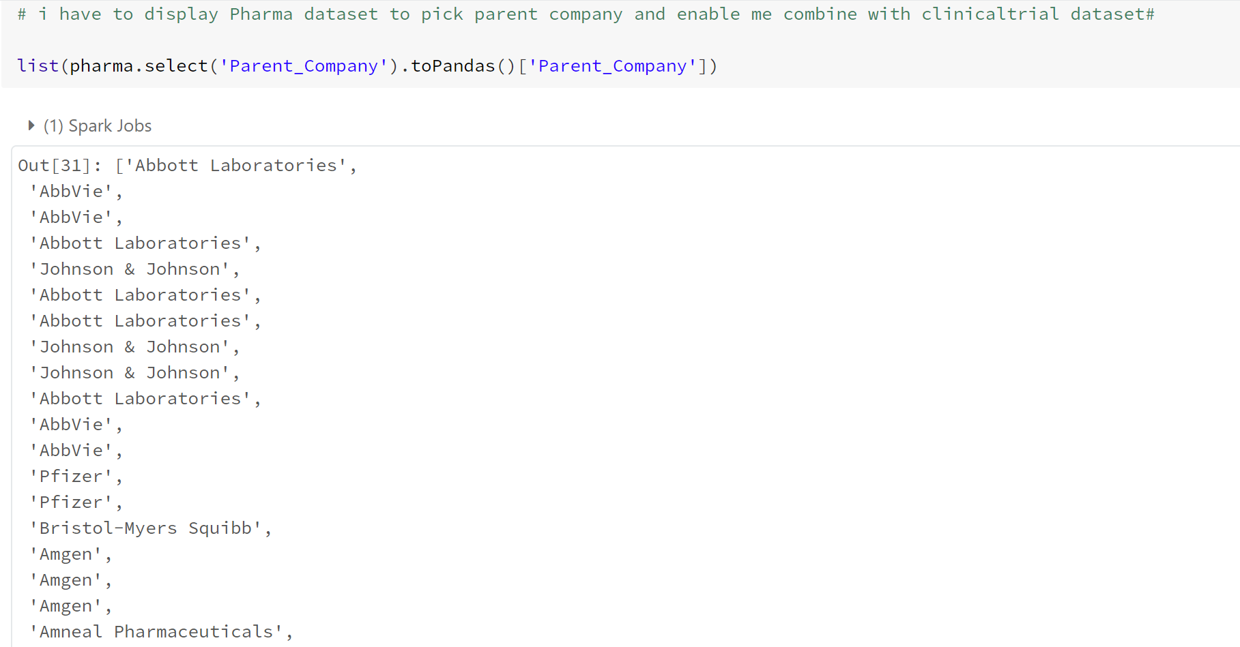

1. Parent variable assigned to select company name from pharma with list function using pandas and select function to select Sponsor ,then group by Sponsor and order by count.

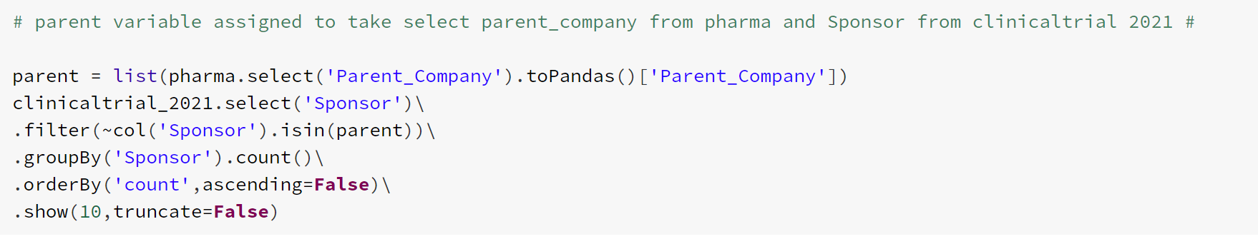

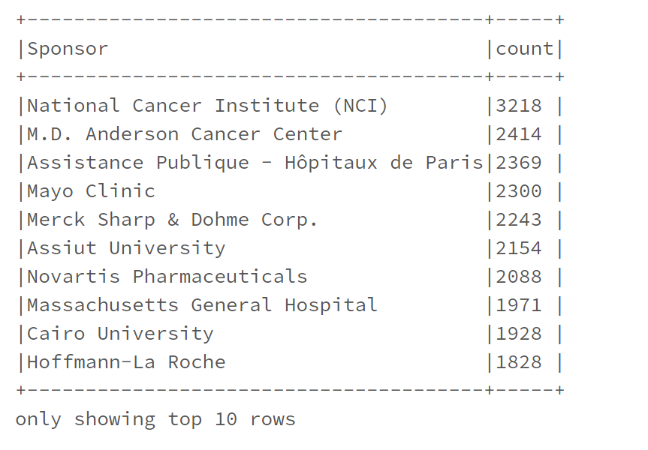

**QUESTION 6 RDD**

**ASSUMPTION:**

1. It is assumed that status is in index two and completion is in index 4,because that is the column of interest for this analysis.
2. All the months are arranged in descending order

**IMPLEMENTATION:**

1.The data was mapped with column 3 and 5 filtered i.e., index 2 and 4, respectively.

2. Also filtered function used to extract completed from Status column

3. filter to remove punctuations, then split by space

4. Filtered completion year 2021 from completion column, then groupbykey.

**Code below shows implementation**.

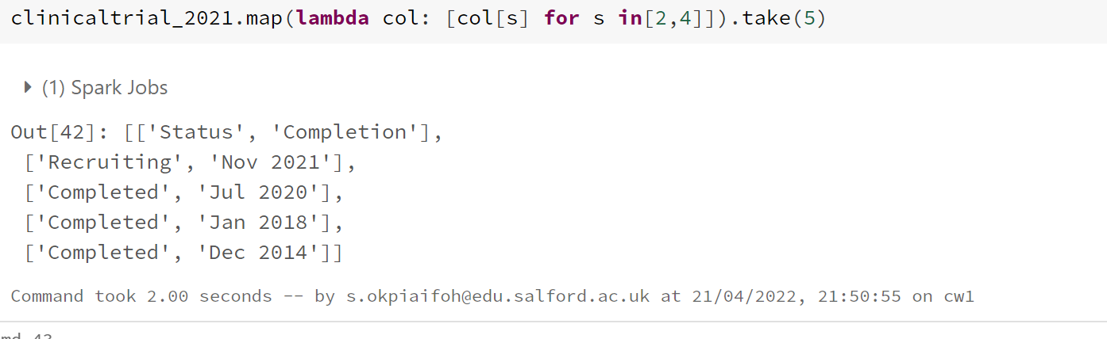

Code displaying column” Status” and “Completion”

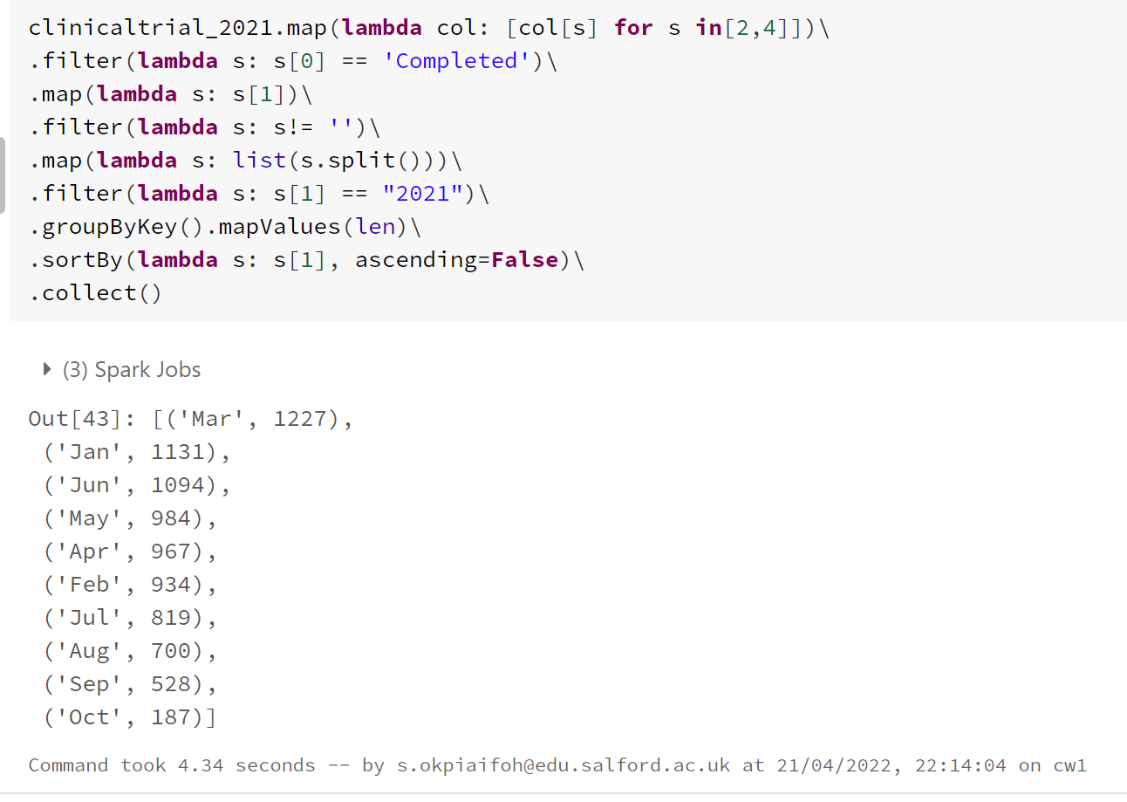

Above result for Question 6 needs to be displayed in descending order of months from January to December, due to size it was truncated to October. To do this I assign above code to variable name called FINAL, then a function created called MONTH_CHANGE.

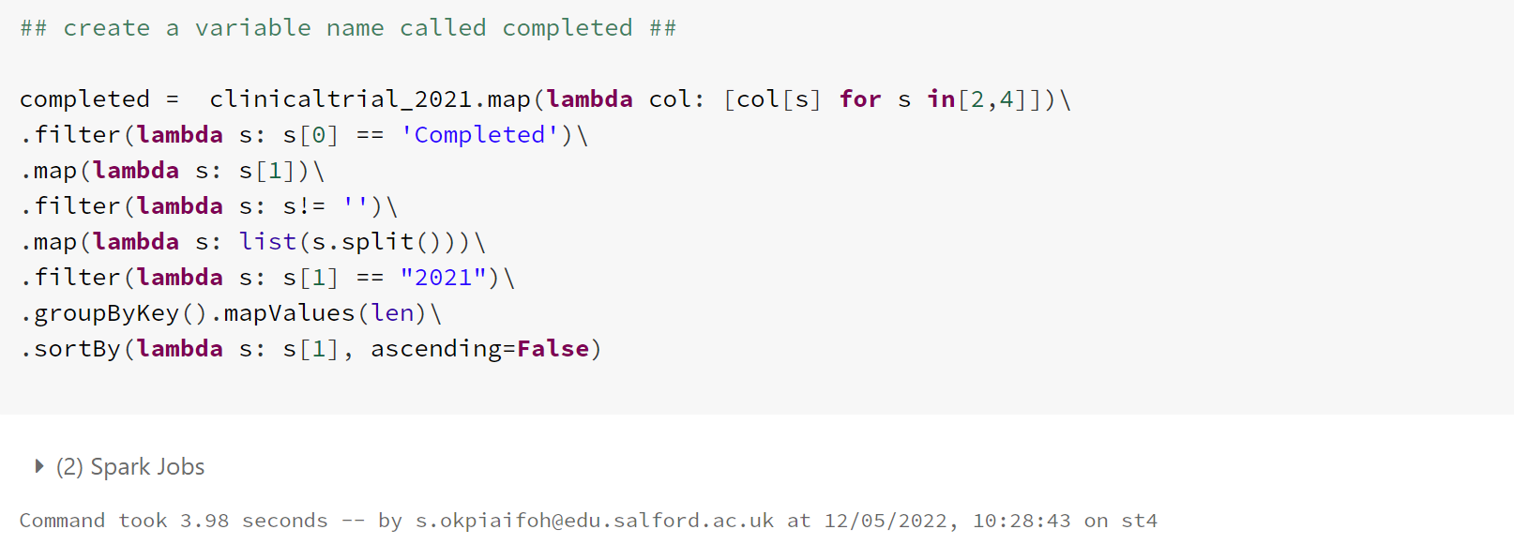

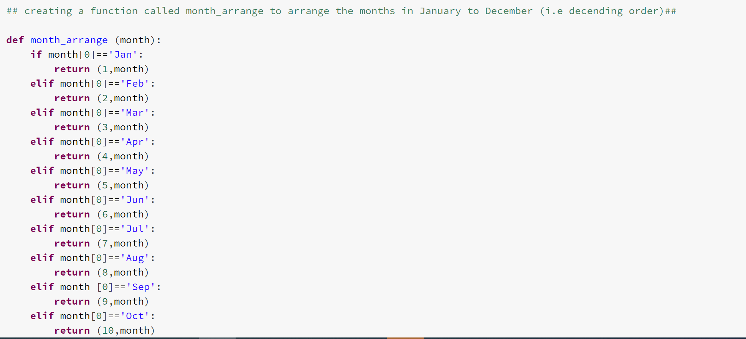

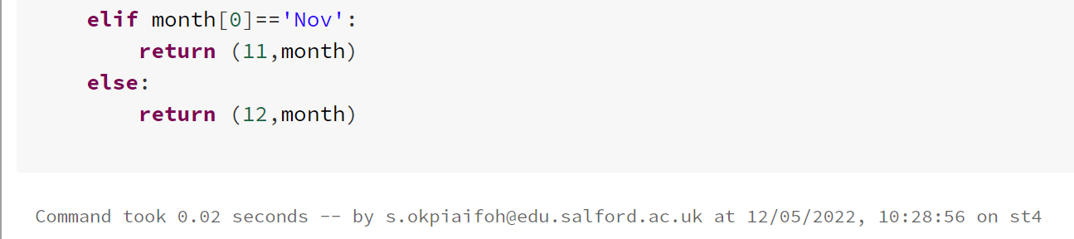

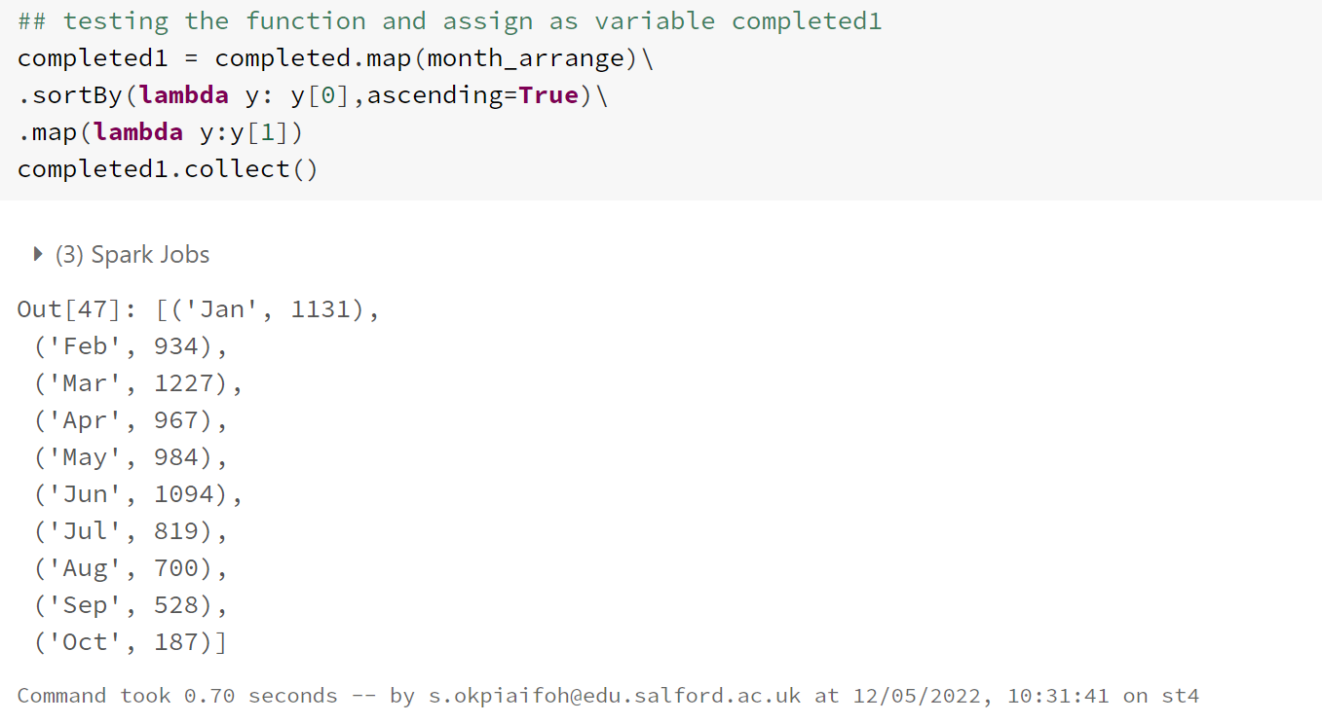

Above code shows months sorted in descending by month applying the function created with flat Map and map functions.

**QUESTION 6 VISUALIZATION IN RDD**

1. Setup Matplotlib from pyspark
2. Assumed months arrange ascending order from the January to December

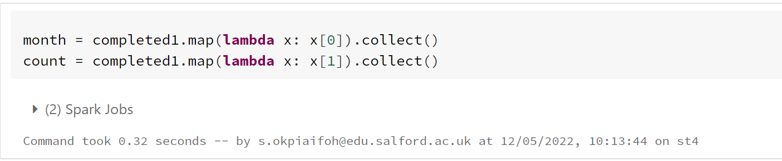

Code above is used to create the x and y axis for plotting purposes

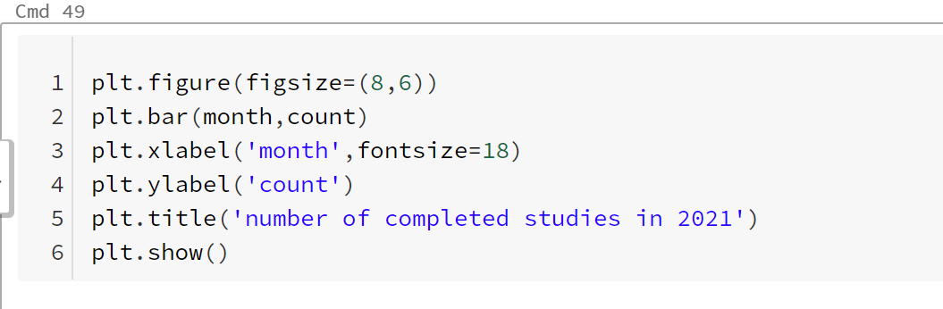

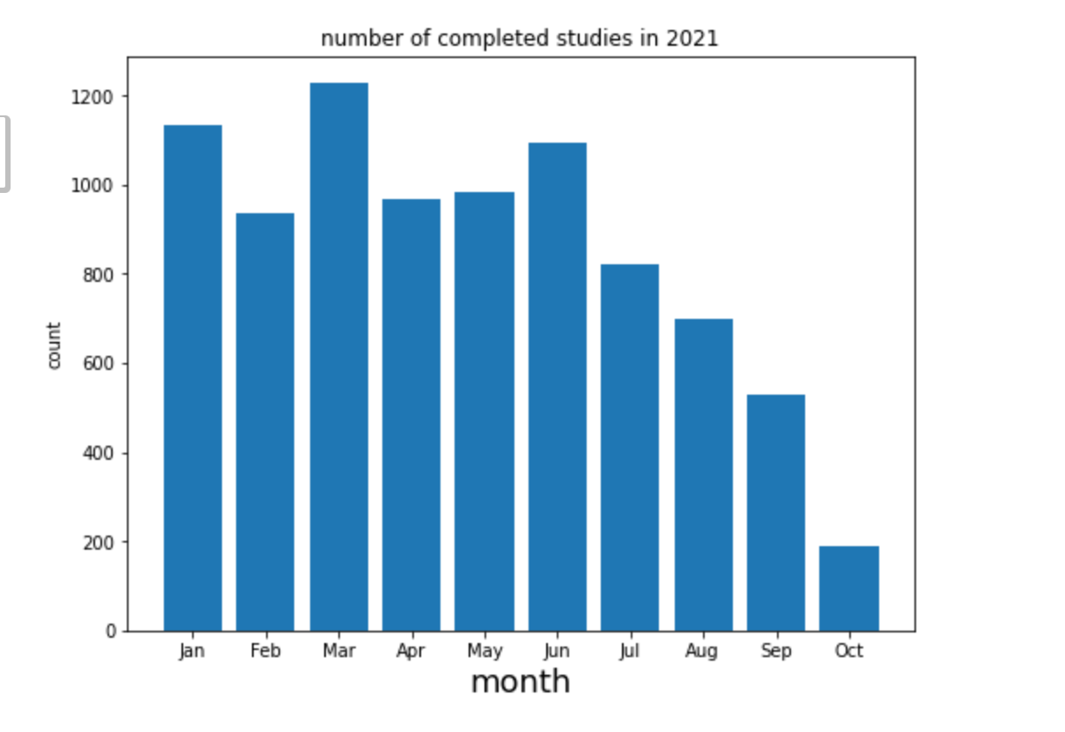

From the above result month of March has the highest study and month of October has the lowest study.

**QUESTION 6 HIVEQL**

Assumption made:

1. All the number of completed studies is contained in status column which is index two
2. The year and month of completion of each study is seen in Completion column index four
3. It assumed that the Completion (year and month) is not null, or the records does not contain blank space.

Implementation outline:

1. From the clinicaltrial 2021 dataset I must use select clause to filter completion from the left, which is the month as month, and count all as frequency
2. Use where clause to filter and make a logical statement that Status is equal to Completed.
3. Completion is not null, filter from right of completion records which is the year e.g., 2021
4. Finally group by month and descending order by frequency.

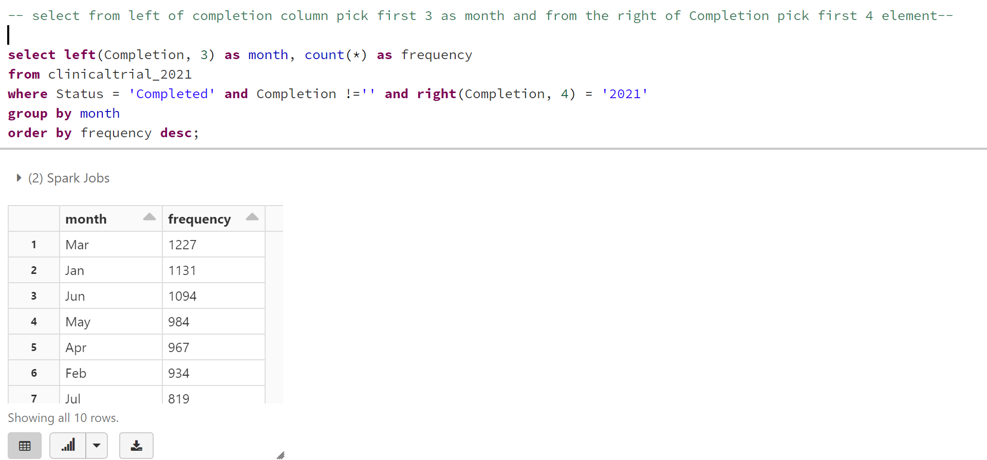

**QUESTION 6 VISUALAZATION DATA FRAME**

1. set up and load the matplotlib from pyspark called plt

2. assumed that all the months arrange in ascending order from January to December

IMPLEMENTATION :

1. A variable name visual, visual1 and visual2 created to enable me to assign the month and count in descending order.
2. A column name called new_month created and assigned a number to each month accordingly.

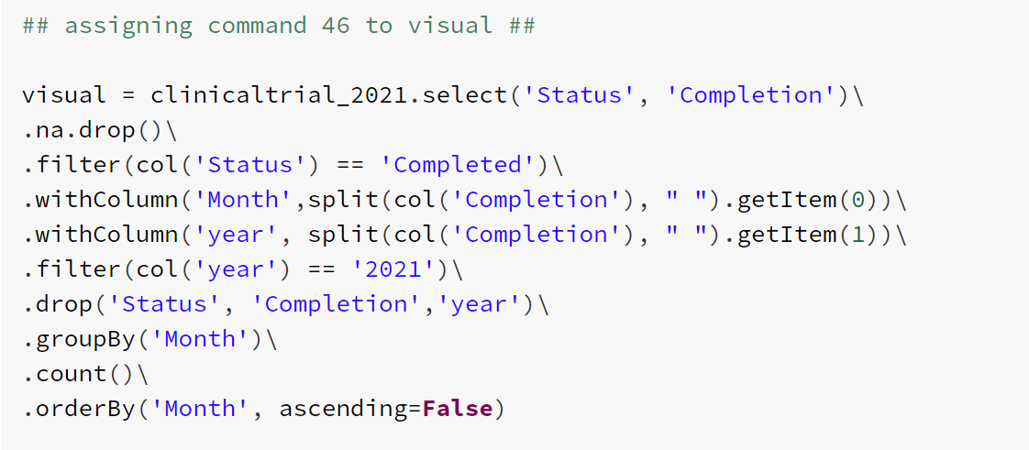

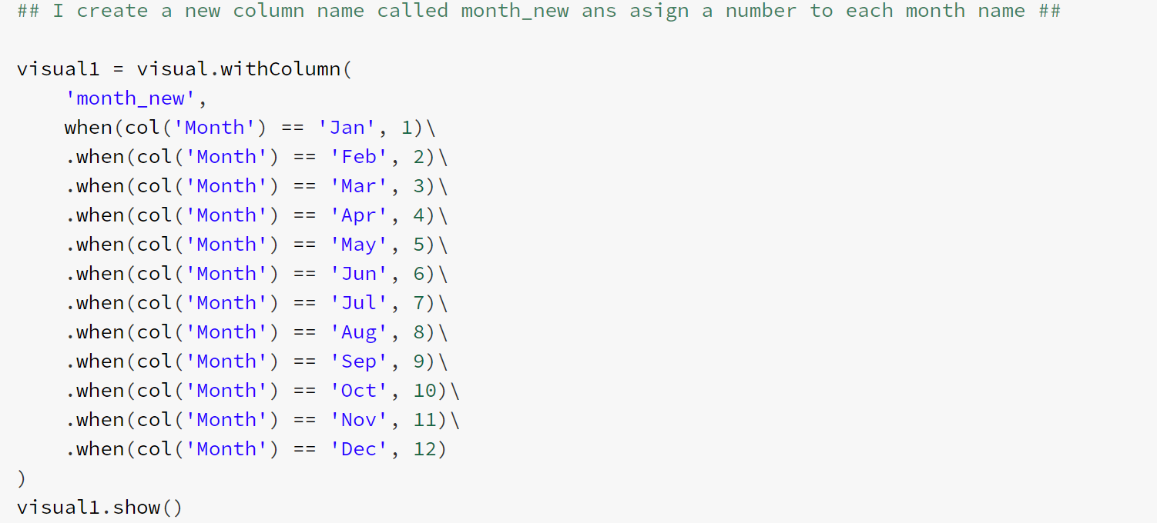

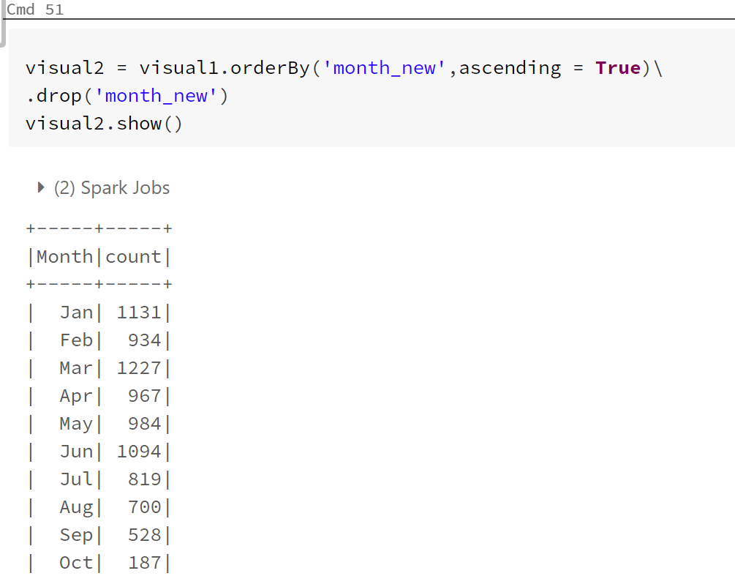

The code below defines x and y axis for the bar chart plot, I am using bar plot because the data involved with months and count.

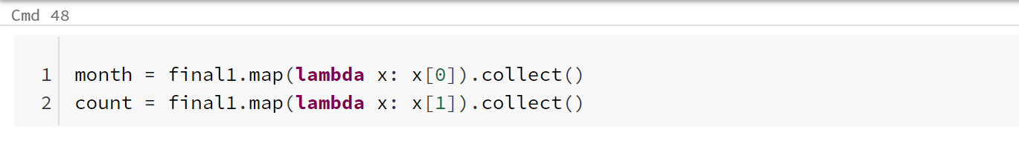

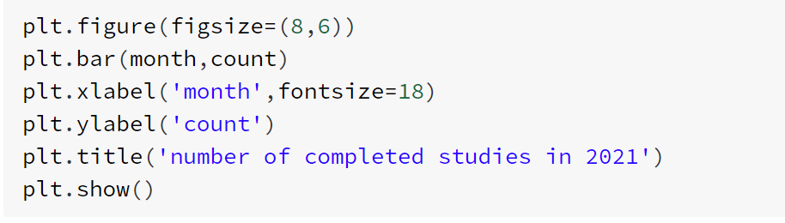

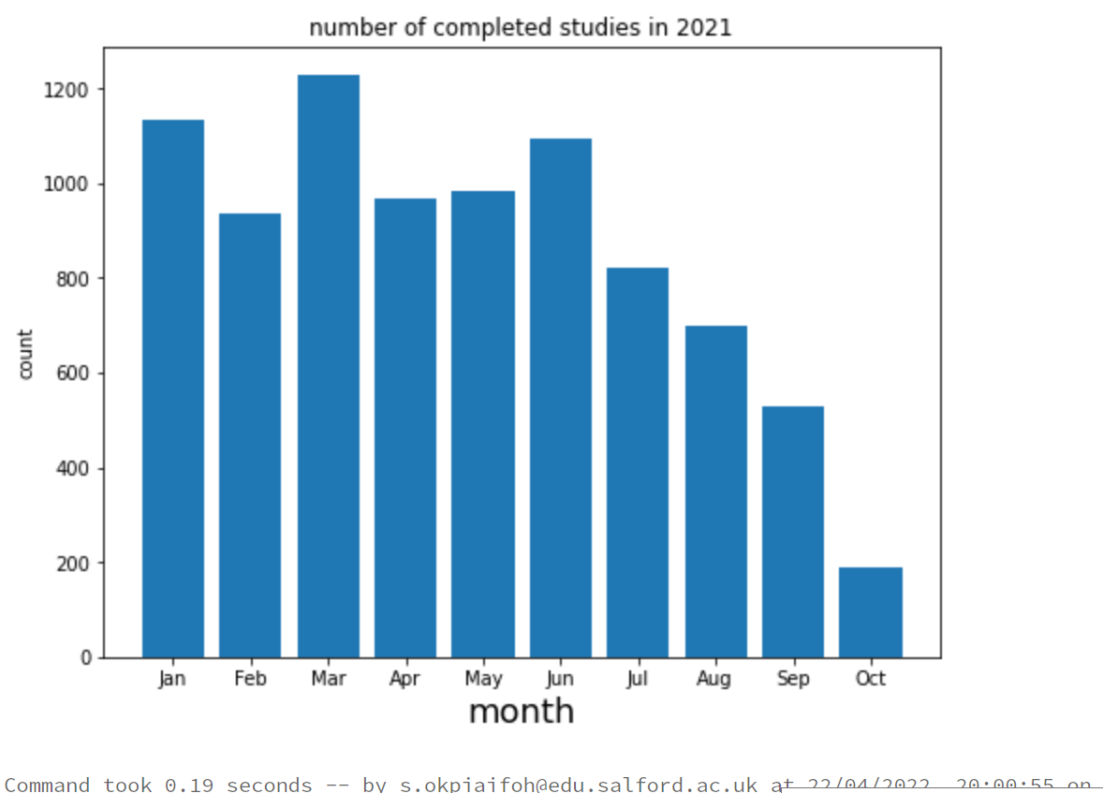

**DISCUSSION OF RESULTS**

Question 1

The number of studies in the dataset is found in the clinicaltrial dataset, from count the total studies in all the years available in the dataset is 387261 studies, which is quite large to process at a time. It also contains sufficient information to answer various business questions

Question 2

listing all the types of treatment from clinicaltrial dataset necessary for each disease by the most frequently occurrence of the disease will give an insight into what necessary measures in terms of drugs and skills that needs to be provided for a particular disease, to be treated effectively. It will help health organization and government to prioritize resources. From the chart below interventional treatment have the highest compared to the observational. While expanded access is the least.



Question 3

The top five conditions with their frequencies indicate most occurred disease in the dataset, this enables the client to understand disease affecting the public and differentiate the ages it can affect either infant, young or old and create necessary awareness and immunization accordingly. Carcinoma, diabetes mellitus falls mostly within population age of 50 years and above, this disease calls for concern as it is very deadly.



Question 4

Each condition can be mapped to one or more hierarchy codes. This question enables a code from mesh dataset to be mapped to conditions. For easy reference in the sense that, the client just a click on code can determine the condition associated with the code and frequencies of the conditions in a glance. The frequencies can be seen from the bar chart below. Code CO4 and C23 is the most common root then C10 is the least root.

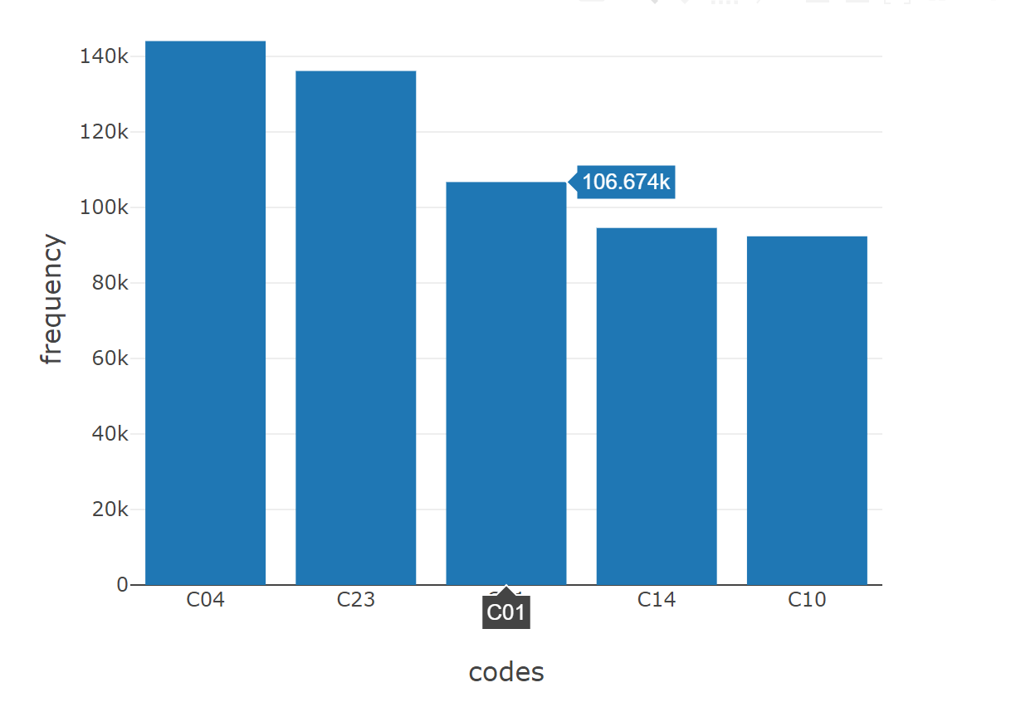

Question 5

The ten most common sponsors that are not pharmaceutical companies, along with the number of clinical trials they have sponsored shows the impact of other companies not in the pharmaceutical industries, but still sponsoring resources needed to promote interventions for disease control and treatment. The bar chart shows frequencies, National cancer institute and M.D . Anderson Cancer Centre tops the list.

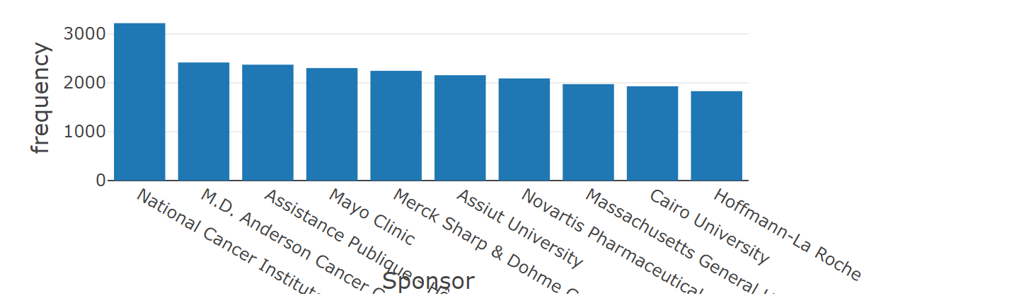

Question 6

The question displays each month with it number of completed studies, this will enable clients to evaluate and review progress based on completed studies, the month and year completed. From the bar chart it shows we have more completed studies in March, January, and June and least in October.

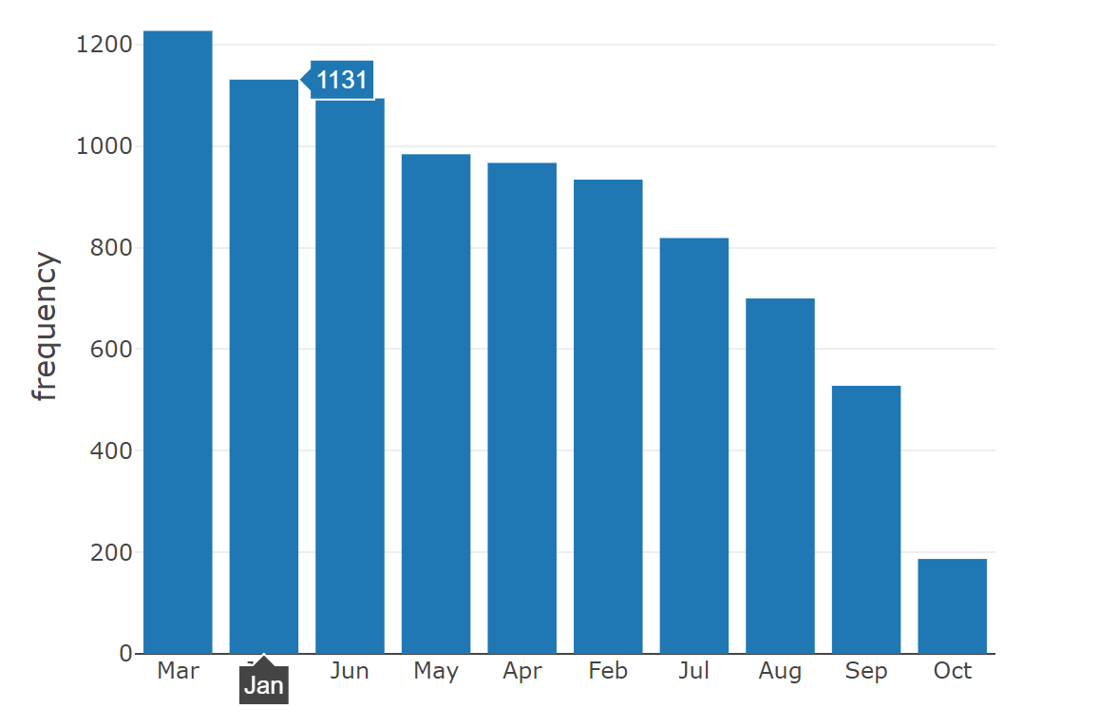

**FURTHER ANALYSIS IN HIVEQL WITH VISUALIZATIONS**

Further to my motivation, the stakeholders may want to compare Sponsors that are recruiting and Sponsor that are active, but not recruiting. This will help to know sponsor and their Status.

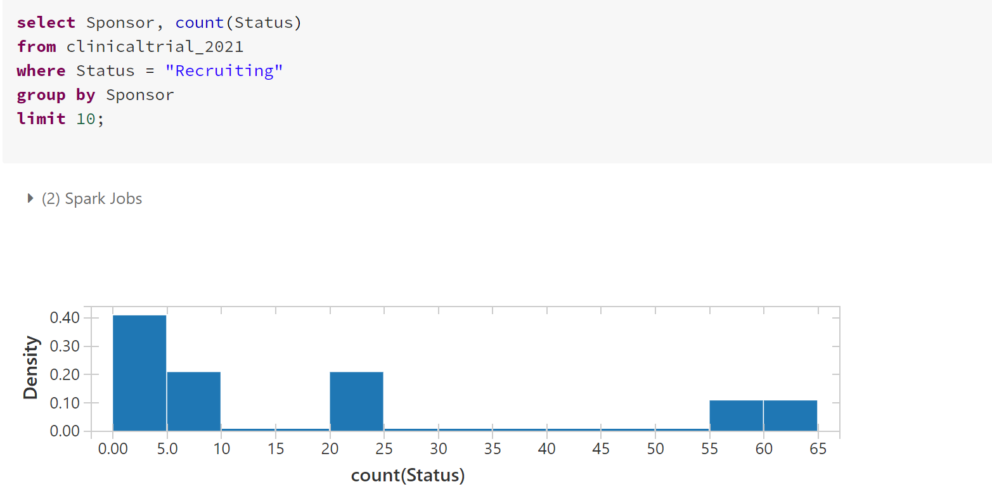

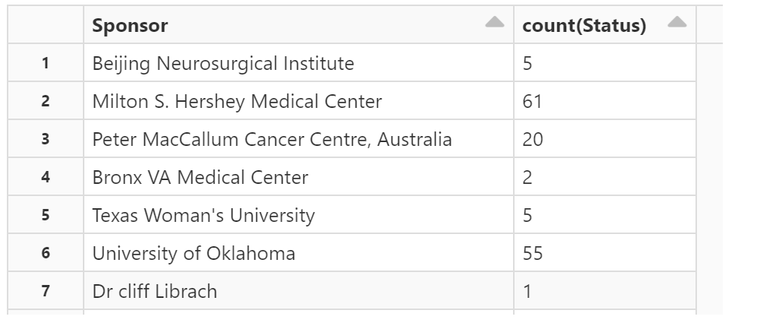

Table showing Sponsor with “Recruiting” Status

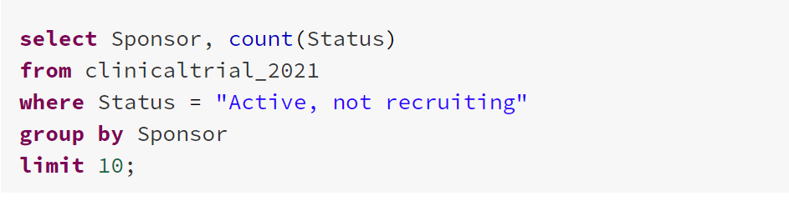

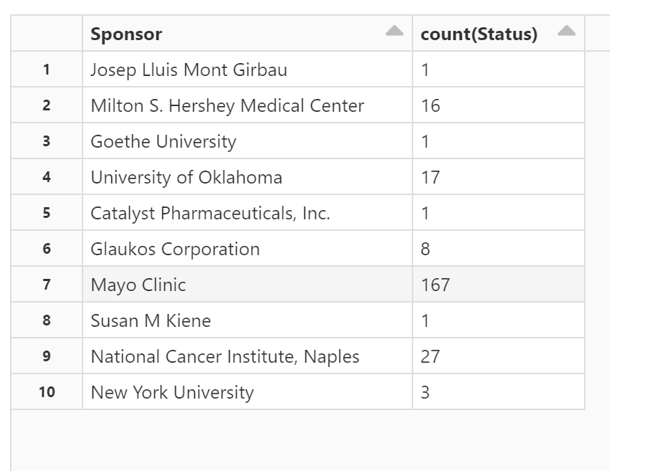

Table showing the sponsor with active, not recruiting “Status.”

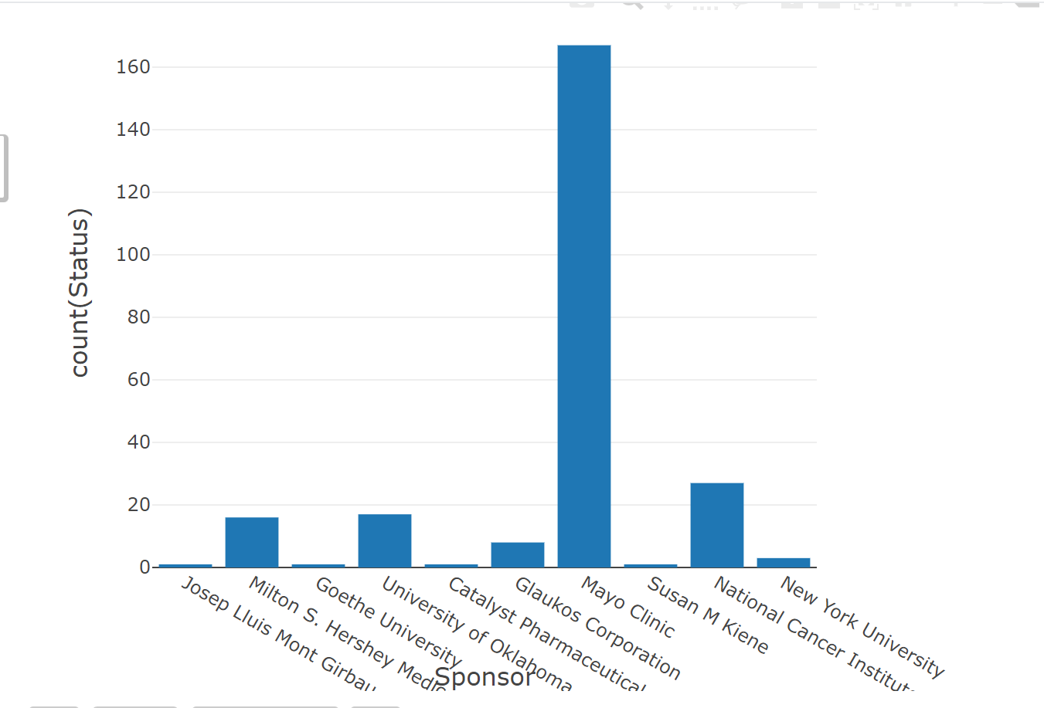

From the above visualization it observed that Mayo clinic has more active, not recruiting status from other sponsors.